Poverty Trends in Ghana in the 1990s



Ghana Statistical Service
October 2000

Poverty Trends in Ghana in the 1990s

Ghana Statistical Service
October 2000

Copyright © 2000 Ghana Statistical Service

Ghana Statistical Service
P O Box GP 1098
Accra

Preface

This report presents an up-to-date analysis of poverty patterns and trends in Ghana, based on the results of the Ghana Living Standards Survey (GLSS). The GLSS is a multi-topic household survey, designed to provide comprehensive information on the living standards of Ghanaian households. So far, four rounds have been completed (in 1987/1988, 1988/1989, 1991/1992 and 1998/1999), each round covering a nationally representative sample of households spread over a full 12-month period. This report focuses on the last two rounds, tracing poverty trends in the 1990s.

The report examines poverty patterns and trends from three broad perspectives: consumption poverty, household assets, and human development. It aims to help improve understanding of living conditions in Ghana, especially among the poorer segments of the population. This report should help planners and policy makers in Ghana design and implement appropriate poverty reduction strategies.

The Statistical Service has also published a companion report, providing more comprehensive description of the results of GLSS 4 (1998/1999). In addition to preparing these reports, the Statistical Service is keen to conduct further analysis of these data, and to encourage others to analyze the GLSS in order to inform public policy.

This report has been prepared by the Ghana Statistical Service (GSS). The research team responsible for the background analysis and preparation of the report comprised Harold Coulombe and Andrew McKay, under the overall supervision of Dr. Kwaku A. Twum-Baah (Acting Government Statistician). Adams Kasanga , Abena Ani and Jacqueline Anum of the GSS provided key technical support. Gabrielle Cournoyer helped in editing the document. Support has also been provided by the World Bank, and the report has benefited from comments by Sudharshan Canagarajah (Task Manager) and Lionel Demery (Lead Specialist) both of the World Bank.

The Statistical Service also wishes to acknowledge the financial support of the Government of Ghana, the World Bank, and the European Union in the implementation of the GLSS 4 and the support of DFID and Canadian Trust Fund for the data analysis.

October 2000 | DR. KWAKU A. TWUM-BAAH  ACTING GOVERNMENT STATISTICIAN  GLSS PROJECT TECHNICAL DIRECTOR

TABLE OF CONTENTS

Preface iii
List of tables and figures vi

1 Introduction 1
2 Consumption Poverty : Methodology 2
Data sources; Measurement Issues; Construction of the new
Standard of living measure ; Setting the poverty line.

3 Patterns and changes in consumption poverty 7
Poverty trends in the 1990s ; Extreme Poverty ; Depth of
Poverty ; Poverty by region ; Poverty by main economic activity ;
Robustness of observed poverty trends ; Proximate determinants
Of poverty change

4 Poverty in terms of Assets and human development : Methodology 19

5 Household Assets and access to Service 20
Household assets ; Housing characteristics

6 Human development 27
Health ; Education

7 Concluding observations 33

References 34

Appendix 1 Main tables – Consumption Poverty Indices 35
Appendix 2 Main tables – Household assets and access to Services 41
Appendix 3 Main tables – Human Development Indicators 49
Appendix 4 GLSS Sample Design 57
Appendix 5 Construction of the standard of living measure 58
Appendix 6 Setting a Poverty Line for Ghana 64
Appendix 7 Poverty Indices 68

LIST OF TABLES AND FIGURES

Table 1 Regional cost of living indices 4
Table 2 Poverty by location, 1991/92 and 1998/99 (percent) 8
Figure 1 Poverty incidence (P₀) by locality, 1991/92 and 1998/99 9
Figure 2 Population shares and contribution to poverty incidence
(C₀) by locality (percent) 10
Figure 3 Extreme poverty incidence (P₀) by locality, 1991/92 and 1998/99 11
Figure 4 Income gap ratios ( P₁/ P₀ ) by locality, 1991/92 and 1998/99 12
Figure 5 Poverty incidence (P₀) by administrative region, 1991/92 and 1998/99 13
Figure 6 Poverty incidence (P₀) by main economic activity, 1991/92 and 1998/99 14
Figure 7 Poverty Incidence Curves, Ghana, 1991/92 – 1998/99 15
Table 3 Decomposition of change in poverty incidence 1991/92 – 1998/99, by location 17
Figure 8 Percentage of households owning different household assets – Urban Areas 23
Figure 9 Percentage of households owning different household assets – Rural Areas 23
Figure 10 Percentage of households owning a Refrigerator, by locality and
standard of living 24
Figure 11 Percentage of households owning a TV, by locality and standard of
living quintile 24
Figure 12 Percentage of households having access to potable water, by locality and
standard of living quintile 25
Figure 13 Percentage of households using a flush or a KVIP toilet, by locality and
standard of living quintile 25
Figure 14 Percentage of households using electricity, by locality and standard
of living quintile 26
Figure 15 Percentage of ill or injured individuals that consulted a doctor or
a pharmacist, by locality and standard of living quintile 30
Figure 16 Percentage of ill or injured individuals that went to hospital, by
locality and standard of living quintile 30
Figure 17 Net enrolment rates in primary school, by gender and locality 31
Figure 18 Net enrolment rates in primary school, by gender and standard of living quintile 31
Figure 19 Net enrolment rates in secondary school, by gender and locality 32
Figure 20 Net enrolment rates in secondary school, by gender and standard of
living quintile 32

Table A1.1 Indices of extreme poverty by location, 1991/92 and 1998/99
Poverty line = 700,000 cedis 35
Table A1.2 Indices of poverty by location, 1991/92 and 1998/99
Poverty line = 900,000 cedis 36
Table A1.3 Indices of extreme poverty by main economic activity, 1991/92 and 1998/99
Poverty line = 700,000 cedis 37
Table A1.4 Indices of poverty by main economic activity, 1991/92 and 1998/99
Poverty line = 900,000 cedis 38
Table A1.5 Indices of extreme poverty by region, 1991/92 and 1998/99
Poverty line = 700,000 cedis 39
Table A1.6 Indices of poverty by region, 1991/92 and 1998/99
Poverty line = 900,000 cedis 40

Table A2.1 Percentage of households owning different physical assets, by location,
1991/92 and 1998/99 41
Table A2.2a Percentage of households owning different physical assets,
by standard of living quintile – Urban areas 42
Table A2.2b Percentage of households owning different physical assets,
by standard of living quintile – Rural areas 43
Table A2.3a Main source of drinking water of households by standard of
living quintile – Urban Areas 44
Table A2.3b Main source of drinking water of households by standard of
living quintile – Rural Areas 45
Table A2.4a Toilet facilities used by households by standard of
living quintile – Urban Areas 46
Table A2.4b Toilet facilities used by households by standard of
living quintile − Rural Areas 47
Table A2.5 Percentage of households using electricity, by locality and quintile 48

Table A3.1a Type of health personnel consulted by ill or injured individuals, by
standard of living quintile – Urban Areas 49
Table A3.1b Type of health personnel consulted by ill or injured individuals, by
standard of living quintile – Rural areas 50
Table A3.2a Where consultation took place for ill or injured individuals, by
standard of living quintile – Urban Areas 51
Table A3.2b Where consultation took place for ill or injured individuals, by
standard of living quintile – Rural Areas 52
Table A3.3 Net enrolment in primary school, by locality, gender and standard of
living quintile 53
Table A3.3 Net enrolment in primary school, by locality, gender and standard of
living quintile (contd ) 54
Table A3.4 Net enrolment in secondary school, by locality, gender and standard of
living quintile 55
Table A3.4 Net enrolment in secondary school, by locality, gender and standard of
living quintile (contd) 56

Table A5.1 Estimation of total household consumption expenditure from the GLSS3
and 4 surveys 62
Table A5.2 Recommended energy intakes 63

Table A6.1 Estimated poverty lines based on different consumption baskets
(cost of basic needs method) 67
Table A6.2 Coefficients of main variables in food share regression equations 67

I. INTRODUCTION

This report describes poverty trends in Ghana during the 1990s. The setting is one of a relatively buoyant economy, which has achieved positive per capita economic growth rates during the decade. GDP is estimated to have grown on average by 4.3 percent per annum during the 1992-1998 period. To what extent have Ghanaian households and communities benefited from this growth? Which groups have benefited most? Have the lives of poor Ghanaians improved as a result? What has been the impact of recent economic growth on poverty in the country?

Poverty in Ghana has many dimensions. Poor communities are characterised by low income, malnutrition, ill health, illiteracy, and insecurity. There is also a sense of powerlessness and isolation. These different aspects interact and combine to keep households, and at times whole communities, in persistent poverty. As evidenced by actions taken to effectively reduce poverty globally, policies must be comprehensive and based on timely information on the living standards of the population.

This report focuses on three dimensions of poverty: consumption poverty; lack of access to services and limited human development. It brings to the policy debate in Ghana the results of the fourth round of the Ghana Living Standards Survey (GLSS), which was conducted by the Ghana Statistical Service (GSS) over the period April 1998 – March 1999. This is a nationally representative survey, covering a wide range of household characteristics and behaviour. The report compares GLSS data from the 1998/1999 survey with the previous round in 1991/1992, which provides an opportunity to trace trends in household well-being over the decade.

These data have been subjected to careful analysis in order to establish trends in poverty, and to inform public policy. The next section outlines the methodology that has been used for measuring consumption poverty, and discusses the measurement issues that have arisen. Section III then describes the main results on consumption poverty. It shows that while poverty has fallen overall in Ghana during the 1990s, the gains have not been shared by all regions, and have been smaller for the poorest. The report then deals with other measures of well-being that can be derived from the GLSS. Section IV describes the methodological approach. Section V then focuses on household assets and other characteristics (such as access to electricity and water) as they relate to household welfare. Human development indicators (such as education and health) are then reviewed in Section VI. Concluding observations are made in the final section.

II. CONSUMPTION POVERTY: METHODOLOGY AND MEASUREMENT

A report on consumption poverty is specifically concerned with those whose standard of living falls below an adequate minimum defined by a poverty line. In putting this into practice two important issues need to be addressed:

- the measurement of the standard of living; and

- the selection of a poverty line.

In this study, following common practice in many countries, a consumption-based standard of living measure is used. The poverty line will be set as that level of the standard of living measure at which minimum consumption requirements can be met.

Data sources

The data on which this study is based are those derived from the third and fourth rounds of the Ghana Living Standards Survey (GLSS). The GLSS is a multi-purpose survey of households in Ghana, which collects information on the many different dimensions of their living conditions. These data are collected on a countrywide basis. Four rounds of data have been collected, starting in 1987-1988. In this report we focus on the two most recent rounds—those conducted in 1998-1999 and in 1991-1992. The questionnaires used for these two rounds were almost identical, meaning that their results can be directly compared. By contrast, the first two rounds were based on different questionnaires, making comparison with the later rounds more difficult.

Among other things, the GLSS surveys collect sufficient information to estimate total consumption of each household. This covers consumption of both food and non-food items (including housing). Food and non-food consumption commodities may be explicitly purchased by households, or acquired through other means (e.g. as output of own production activities, payment for work made in the form of commodities, or from transfers from other households). The household consumption measure must take account of all of these sources, and the questionnaire enables this to be done (Appendix Table A5.1 has the details).

Measurement issues

In using measures of household consumption to compare living standards across the country, it is necessary to take account of variations in the cost of living across households, as well as differences in their size and composition. The latter can be taken to reflect the consumption needs of the household—larger households have greater consumption needs.

The previous Ghana Statistical Service publication, The Pattern of Poverty in Ghana, 1988-1992 (GSS, 1995), reported on the first three rounds of the GLSS. After some adjustments to ensure comparability between the rounds, this report concluded that significant reductions in consumption poverty occurred between the second round (1988-1989) and the third (1991-1992). Here we focus on trends in consumption poverty in more recent years, comparing living standards and poverty measures derived from the latest round (1998-1999) with those from the third (1991-1992). The report therefore highlights poverty trends in the 1990s. All comparisons between GLSS 3 and GLSS 4 presented here are based on the same (new) methodology, and so are comparable with each other.

The results reported here are not strictly comparable with the previous Pattern of Poverty report. Although the same broad methodological approach is taken, important improvements in the measurement of both the standard of living and the poverty line are applied in the current report (Appendices 5 and 6 have the details). These can be summarised as:

- a refinement of the household consumption aggregate to exclude items not considered appropriate in a measure of the standard of living (these include expenditures on major hospital treatment and on transfers made to other households);

- the use of adult equivalent scales in the measurement of household size, reflecting the differing consumption needs of household members (the previous report simply took household consumption per capita as the living standard measure);

- the use of a more reliable regional price index, based on the price data obtained from the GLSS 4 round (replacing the estimates obtained from GLSS 3);

- the use of poverty lines which are explicitly based on nutritional requirements (replacing the previous poverty lines which were computed as ratios of mean consumption in 1987/1988).

It should be emphasised that these are unambiguous improvements in the measurement of poverty. Overall, they yield higher estimates of poverty in Ghana than previously derived. Whereas GSS (1995) reported the incidence of poverty for the country as a whole to be 31.4 percent in 1991/1992, the revised estimate for 1991/1992 based on the upper poverty line is 51.7 percent, and based on the lower poverty line, 36.5 percent. Though higher, the latter estimates are preferred. Poverty incidence based on the new lower poverty line is closest to the previous estimate.

In summary, the measurement of both the standard of living and poverty line have been refined and improved. These better measures yield higher levels of poverty in Ghana than previously reported. The previous estimate, however, is broadly consistent with the results reported here using the new lower poverty line.

Construction of the new standard of living measure

As before, the measure of the standard of living is based on household consumption expenditure, covering food and non-food (including housing), but with the exclusions referred to above. The regional cost of living index based on GLSS 4 compares the cost of a given consumption basket in each of five localities with the cost of the same basket in Accra. The index is presented in Table 1. It indicates that there are significant differences in the prices of food and housing, with urban areas in general and Accra in particular being more expensive for these items than rural areas. The prices of other non-food items are much more uniform. The regional cost of living index is a weighted average of these three regional sub-indices.

Table 1: Regional cost of living indices

 | Food index | Non food index | Housing index
Accra | 1.0000 | 1.0000 | 1.0000
Other Urban | 0.9183 | 0.9086 | 0.6442
Rural Coastal | 0.8832 | 0.9753 | 0.6149
Rural Forest | 0.8212 | 0.9839 | 0.5296
Rural Savannah | 0.7310 | 1.0484 | 0.4491
Source: Computed from the Ghana Living Standards Survey, 1998/1999.

The overall cost of living index also allows for variation in prices over time within and between the sample years, based on the Consumer Price Index. In this way, each household’s consumption expenditure is expressed in the constant prices of Accra in January 1999.

Household size is measured as the number of equivalent adults, using a calorie-based scale from the 10th Edition of the National Research Council’s Recommended Dietary Allowances (Washington D.C.: National Academy Press, 1989). This scale has commonly been applied in nutritional studies in Ghana. Measuring household size in equivalent adults recognises for example that the consumption requirements of babies or young children are less than those of adults. The scale is based on age and gender specific calorie requirements, and is given in Table A5.2 (in Appendix 5). This scale is particularly relevant for living standard measures where food shares are high, as in the Ghana case.

Each individual is represented as having the standard of living of the household to which they belong. It is not possible to allow for intra-household variations in living standards using the consumption measure, though some other indicators considered later do take some account of intra-household variations.

In summary, the standard of living for each individual is measured as the total consumption expenditure, per equivalent adult, of the household to which he or she belongs, expressed in constant prices of Accra, January 1999.

Setting the poverty line

The establishment of an absolute poverty line represents the most important point of departure from previous poverty analysis in Ghana. The Pattern of Poverty report used poverty lines defined as specified ratios of mean household consumption per capita in 1987/1988. While these lines corresponded to reasonable levels of calorie intake, there was a clear need to develop absolute poverty lines in Ghana, around which a broad consensus could be built. Such a consensus was achieved through a series of data users seminars in the months leading to the Consultative Group Meeting in November 1999. Setting poverty lines is not an exact science. Analysts must use sound judgement as well as quantitative tools. The approach taken here is to anchor such lines on calorie requirements—that is to use nutrition based poverty lines. The principles used for doing this are discussed in Box 1 and in more detail in Appendix 6. Two nutritionally-based poverty lines are derived from this procedure:

- A lower poverty line of 700,000 cedis per adult per year: this focuses on what is needed to meet the nutritional requirements of household members. Individuals whose total expenditure falls below this line are considered to be in extreme poverty, since even if they allocated their entire budgets to food, they would not be able to meet their minimum nutrition requirements (if they consume the average consumption basket). This poverty line is 49.6 percent of mean consumption levels in 1998/1999.

- An upper poverty line of 900,000 cedis per adult per year: this incorporates both essential food and non-food consumption. Individuals consuming at levels above this can be considered able to purchase enough food to meet their nutritional requirements, and to be able to meet their basic non-food needs. This poverty line is 63.7 percent of mean consumption levels in 1998/1999.

In summary, this report anchors the poverty line on the nutrition needs of the Ghanaian population. It derives two lines: a lower line of 700,000 cedis per adult per year, and an upper line of 900,000 cedis per adult per year.

Box 1: Setting a poverty line for Ghana

Setting an absolute poverty line for a country is not a precise scientific exercise. Though an absolute poverty line can be defined as that value of consumption necessary to satisfy minimum subsistence needs, difficulties arise in specifying these minimum subsistence needs as well as the most appropriate way of attaining them. In the case of food consumption, nutritional requirements can be used as a guide. In practice, this is often restricted to calorie requirements, but even then there remains a difficult issue about which food basket to choose. And specifying minimum requirements for non-food consumption is still more difficult.

In practice, calorie requirements are generally used as the basis for an estimated poverty line. Given information about quantities of foods consumed by households, and about the calorie contents of these foods, there are two common ways in which this can be done. One is to estimate a relationship between the standard of living measure and total calorie intake per adult equivalent; such a relationship can be used to deduce the level of the standard of living measures at which the calorie requirement is satisfied on average. This is an estimate of the overall poverty line which avoids the need to specify minimum non-food consumption requirements.

Probably a better method is by examining the average consumption basket of the bottom x percent (say 50 per cent) of individuals ranked by the standard of living measure, and computing how many calories this basket provides per adult equivalent. The quantities of each item consumed can then be scaled up (or down) in the appropriate proportion to compute the basket with this composition which would provide the minimum calorie requirements (2900 kilocalories per equivalent adult based on the scale used here). This provides an estimate of the food expenditure required to attain 2900 kilocalories, based on the consumption basket of the poorest x per cent of the distribution. Obviously, an issue in this is the choice of x. Taking account of non-food needs is more difficult to judge and subjective. Following common practice in other developing countries, this is set here based on the expenditure devoted to non-food items of those whose total consumption expenditure is at the level of the food poverty line. This is based on the principle that these non-food consumption items are essential for households, so that they will even forgo meeting their calorie requirements (or consume an “inferior” basket) in order to purchase them.

Both of these methods have been examined for the case of Ghana. The results from the first method are sensitive to the precise functional form used to estimate the relationship; however, they suggest poverty lines in the range 850,000 – 950,000 cedis per equivalent adult per year. The second method suggests food poverty line of, in round figures, 700,000 when x=50 percent (slightly lower for lower values of x), while allowing for non-food requirements suggests an overall poverty line of approximately 900,000 cedis per equivalent adult per year. This latter line is consistent with that obtained using the first method, and we set this as the overall poverty line for Ghana. The food poverty line of 700,000 is used as an extreme poverty line; people whose standard of living measures lies below this would not be able to meet their calorie requirements even if they spent their entire budget on food.

III. PATTERNS AND CHANGES IN CONSUMPTION POVERTY

By applying the two poverty lines to the distribution of the standard of living measure, we are able to obtain measures of poverty in Ghana. Two aspects of poverty are of particular interest:

- the incidence of poverty, or the proportion of a given population identified as poor;

- the depth of poverty, or the extent to which those defined as poor fall below the poverty line.

These aspects can be examined for the country as a whole, and for appropriately defined groups of the population.

Various poverty indices are available which are combinations of one or both of these dimensions. These include the widely used P_{α} class of poverty indices, tables for which are presented in Appendix 1 (see also Appendix 7 for more information on these indices). The results reported in this section are based on the standard of living measure, poverty and extreme poverty lines referred to above.

Poverty trends in the 1990s

Our objective in this section is to examine variations in poverty across two dimensions. First, we are concerned with poverty changes over time, focussing on the 1990s. Second, the GLSS data permit us to measure differences in the standard of living and in poverty across sections of the Ghanaian population (across geographical regions and across socio-economic groups). Both dimensions have important messages for economic and social policy in Ghana.

The overall trend in poverty during the 1990s has been broadly favourable in Ghana. Taking the upper poverty line of 900,000 cedis, the percentage of the Ghanaian population defined as poor has fallen from almost 52 percent in 1991-1992 to just under 40 percent in 1998-1999 (see Table 2 and Appendix 1—the results are also illustrated in Figure 1). The decline, however, is not evenly distributed geographically, the poverty reductions being concentrated in Accra and Forest (rural and urban) localities. In the remaining localities, both urban and rural, poverty falls only very modestly, apart from Urban Savannah, where the proportion of the population defined as poor has increased during the period.

Table 2: Poverty by location, 1991/1992 and 1998/1999 (percent)

 | Poverty line = 900,000 cedis |  |  | Poverty line = 700,000 cedis
 | Poverty | Contribution to |  | Poverty | Contribution to
 | Incidence | total poverty |  | incidence | total poverty

GLSS3-1991/1992
Accra | 23.1 | 3.7 |  | 11.3 | 2.5
Urban Coastal | 28.3 | 4.7 |  | 14.2 | 3.4
Urban Forest | 25.8 | 5.5 |  | 12.9 | 3.9
Urban Savannah | 37.8 | 3.9 |  | 27.0 | 3.9
Rural Coastal | 52.5 | 14.4 |  | 32.8 | 12.7
Rural Forest | 61.6 | 35.3 |  | 45.9 | 37.3
Rural Savannah | 73.0 | 32.6 |  | 57.5 | 36.3
Urban | 27.7 | 17.8 |  | 15.1 | 13.7
Rural | 63.6 | 82.2 |  | 47.2 | 86.3
All Ghana | 51.7 | 100.0 |  | 36.5 | 100.0

GLSS4-1998/1999
Accra | 3.8 | 0.8 |  | 1.7 | 0.6
Urban Coastal | 24.2 | 4.8 |  | 14.3 | 4.2
Urban Forest | 18.2 | 5.4 |  | 10.9 | 4.8
Urban Savannah | 43.0 | 5.2 |  | 27.1 | 4.9
Rural Coastal | 45.2 | 16.7 |  | 28.2 | 15.3
Rural Forest | 38.0 | 30.4 |  | 21.1 | 24.8
Rural Savannah | 70.0 | 36.6 |  | 59.3 | 45.5
Urban | 19.4 | 16.3 |  | 11.6 | 14.4
Rural | 49.5 | 83.7 |  | 34.4 | 85.6
All Ghana | 39.5 | 100.0 |  | 26.8 | 100.0
Sources: Table A.1.1 and A.1.2.
Figure 1: Poverty incidence (P₀) by locality, 1991/1992 and 1998/1999 ( Poverty line = 900,000 cedis)
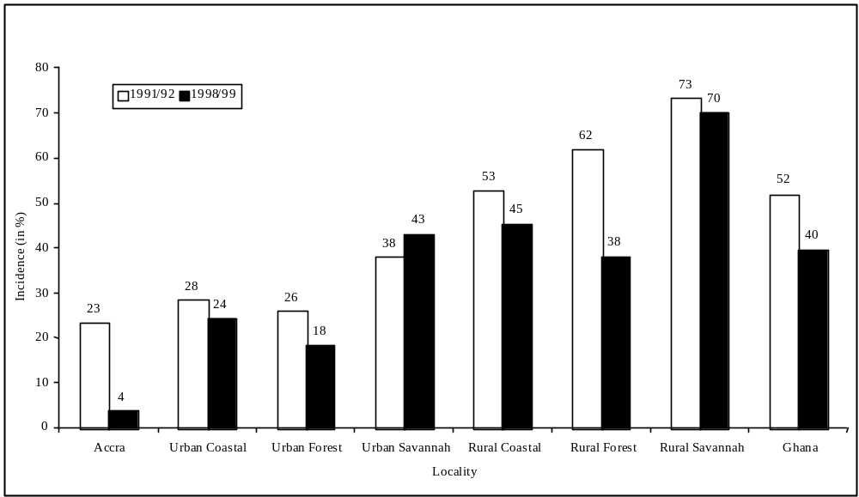 Source: Table A1.2

In both years, poverty is substantially higher in rural areas than urban areas, so that poverty in Ghana is disproportionately a rural phenomenon (Figure 2). Within both urban and rural areas, poverty is disproportionately concentrated in the savannah. This area has benefited very little from the poverty reduction which has occurred at the national level in Ghana. In fact, the mean average welfare measure for Urban Savannah has fallen in absolute value between 1992 and 1998.

Figure 2: Population shares and contribution to poverty incidence (C₀) by locality (percent), 1998/1999 (Poverty line =900,000 cedis)

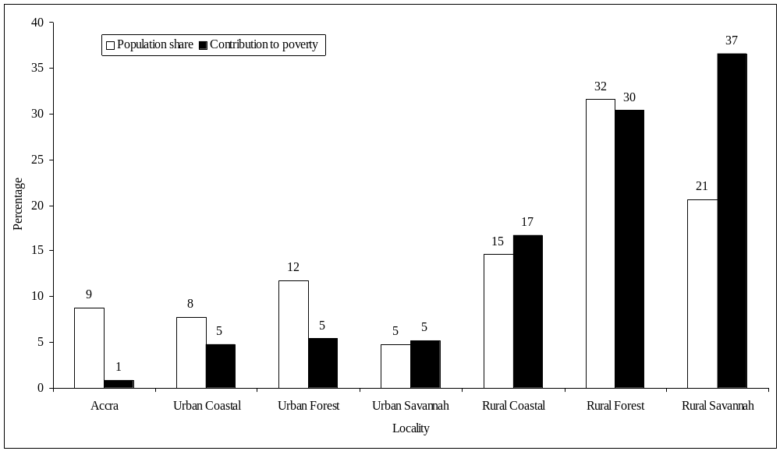
Source: Table A1.2

Extreme poverty

Extreme poverty has been defined as those whose standard of living is insufficient to meet their basic nutritional requirements even if they devoted their entire consumption budget to food. Figure 3 illustrates the trend in the incidence of extreme poverty for the country as a whole and for the same seven geographic localities (the results are also reported in Table 2). At the national level the incidence of extreme poverty has fallen from just over 36 percent in 1991-1992 to just under 27 percent in 1998-1999. The incidence of extreme poverty remains very high in 1998-1999, with over one quarter of the Ghana population being unable to meet their basic nutrition needs, even if they devoted their entire budget to food.

The sharp geographic variations in the pattern of poverty are even more marked with extreme poverty. In both years, more than half of those in the Rural Savannah are classified as extremely poor. The incidence of extreme poverty in this locality actually increases slightly between 1991/1992 and 1998/1999 (in contrast to the observed decline in the incidence of poverty based on the higher poverty line). This tendency for the incidence of extreme poverty to change little where the incidence of poverty falls is also observed in the urban areas of the Coastal and Forest zones. The reduction in poverty in these areas therefore seems to be predominantly among those close to the poverty line, with the very poorest not experiencing significant improvements in their standard of living. This suggests increases in the depth of poverty in these areas. The reduction in extreme poverty has occurred most sharply in Accra and the Rural Forest, which was also the case with the upper poverty line.
Figure 3: Extreme poverty incidence (P₀) by locality, 1991/1992 and 1998/1999
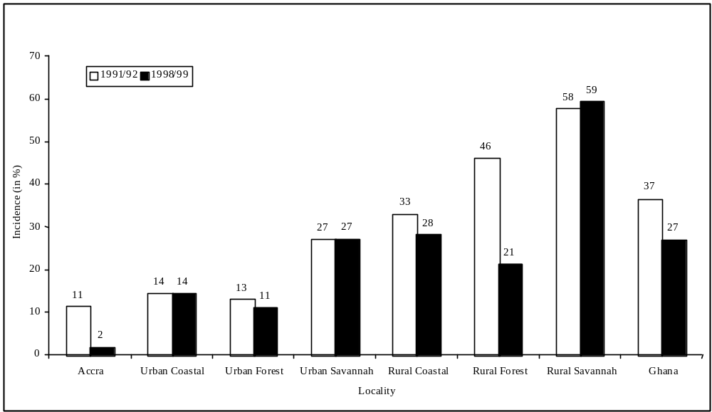 (Poverty line = 700,000 cedis)

Source: Table A1.1

In summary, the incidence of poverty and extreme poverty is indicated to have declined in Ghana during the 1990s, taking the country as a whole. Declines were not uniform across the country, being particularly striking in Accra and in the Forest zone. The decline in poverty in the Savannah was much less marked and, indeed, extreme poverty rose in that locality.

The depth of poverty

The information considered so far only concerns the numbers classified as poor, without considering how poor they are. The income gap ratio, the proportion by which the average consumption level of poor households falls below the poverty line, gives some indication of just how intense poverty has been in Ghana (Figure 4). The average consumption among the poor in Ghana is around 36 percent below the upper poverty line, this figure having decreased only marginally from 1991-1992 to 1998-1999. The corresponding shortfall for the extreme poor is about 30 percent, and this has increased marginally over the period (Appendix 1). This indicates the significant presence of the extreme poor despite the large overall decline in poverty.

In summary, though the incidence of poverty has fallen, the depth of poverty for those who remain poor has remained relatively stable. The depth of poverty is greater at the standard poverty line than at the extreme line.

Poverty by region

It is clear that both poverty itself, and the poverty reduction which has occurred, vary significantly by geographic area. An examination of the pattern of poverty in GLSS 4 by region (Figure 5 and Appendix 1) reveals sharp differences in poverty levels even between geographically adjacent regions. Poverty is lowest by far in Greater Accra and highest in the north of the country (notably the Northern, Upper East and Upper West regions), with dramatic differences between these extremes. The remaining regions lie in between these extremes, but it is important to note that many regions in the south of the country also suffered from a high incidence of poverty in 1998-1999 (e.g. Central, Eastern).

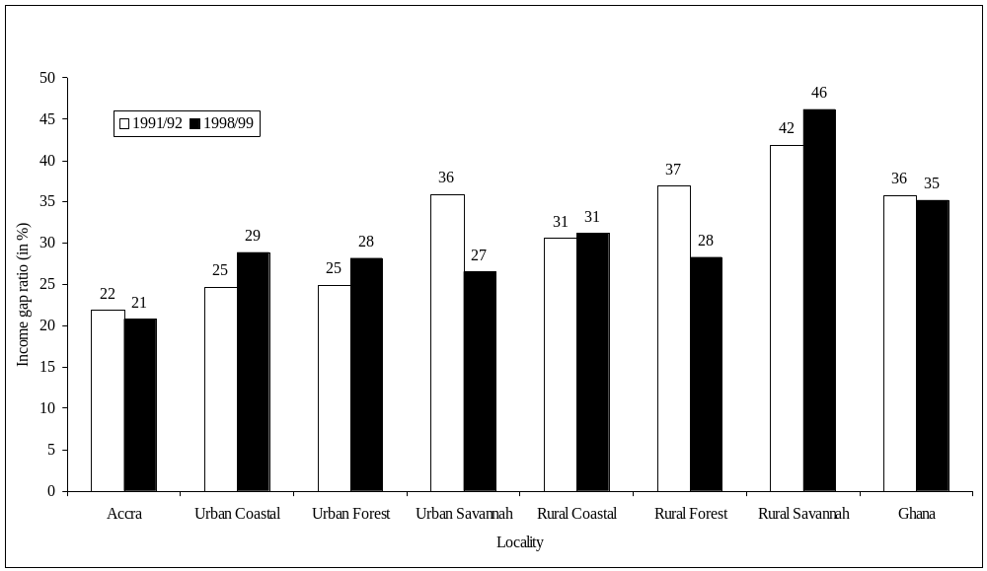
Figure 4: Income gap ratios ( P₁/ P₀ ) by locality, 1991/1992 and 1998/1999
(Poverty line =900,000 cedis)
Source: Table A1.2

The pattern of change in poverty between 1991-1992 and 1998-1999 also varies substantially by region (Figure 5). The significant reductions in poverty at the national level have been concentrated in five regions: Western, Greater Accra, Volta, Ashanti and Brong Ahafo. Other regions (Central, Northern, and particularly Upper East) have experienced increases in poverty between these two periods, while the remaining two regions show only small decreases.

Figure 5: Poverty incidence (P₀) by administrative region, 1991/1992 and 1998/1999
(Poverty line = 900,000 cedis)
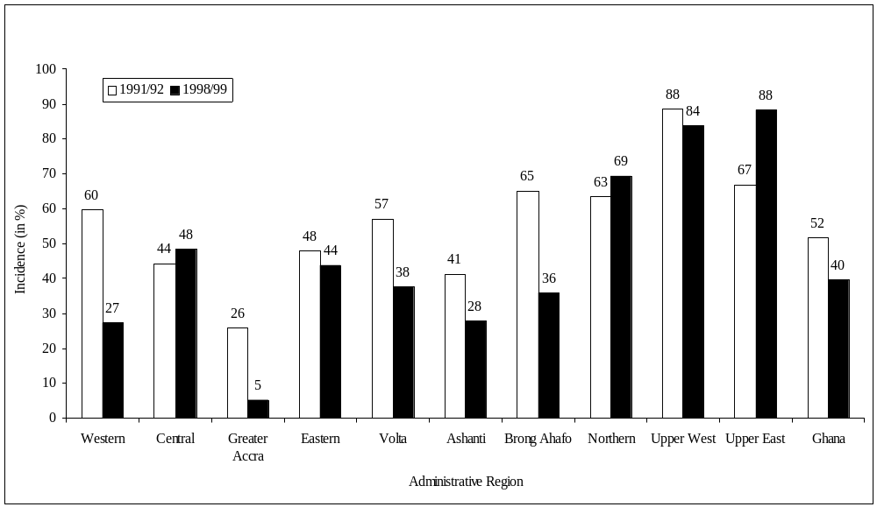
Source: TableA1.6

Poverty by main economic activity

Besides its geographic pattern, it is also important to relate poverty and trends in poverty to the economic activities in which households are engaged. Figure 6 presents the incidence of poverty by the main economic activity of the household. In 1998-1999 in particular, poverty is highest by far among food crop farmers. Moreover, their contribution to the national incidence of poverty is much in excess of their population share. Indeed, at the national level around 58 percent of those identified as poor are from households for whom food crop cultivation is the main activity. Other results not presented here show that the concentration of poverty among food farmers becomes much more pronounced using measures which also take account of the depth of poverty, or when extreme poverty is considered (see Appendix 1 for more information on all this).

Figure 6: Poverty incidence (P₀) by main economic activity, 1991/1992 and 1998/1999
(Poverty line = 900,000 cedis)
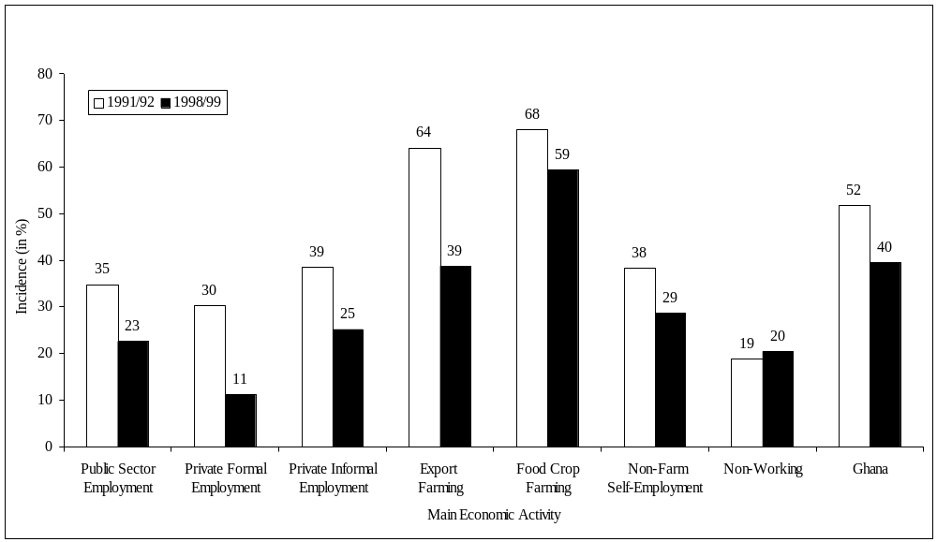
Source: Table A1.4

Other groups represent a smaller share of the national poor than their share of the population. Nonetheless, the incidence of poverty is still quite high among export farmers, private informal sector wage employees and the non-farm self-employed. The last is a big group; in 1998/1999 over 24 percent of the poor in Ghana are from households engaged primarily in non-farm self employment.

Most groups have experienced reductions in poverty over this period, but to differing degrees. Export farmers and wage employees in the private formal sector have experienced the largest reductions in poverty. Poverty has fallen among both wage employees in the public sector and the non-farm self employed (though over this period the number in the former category has fallen significantly, with a corresponding increase in the number working in non-farm self employment). Among food crop farmers the incidence of poverty has fallen by 8.7 percentage points. This is quite a small change relative to other groups, and this is of concern, given the importance of this group and the very high level of poverty among such farmers to begin with. Food crop farmers have experienced less than proportionate share in poverty reduction in Ghana.

The exception to the general reduction in poverty is the non-working category; though this group is small, and not disproportionately poor, it experienced a small increase in the incidence of poverty.

In summary, the declines in poverty have been concentrated mostly in Western, Greater Accra, Volta, Ashanti and Brong Ahafo. Some regions (Central, Northern, Upper East) have experienced increases. Export farmers and wage employees in private employment enjoyed the greatest gains in their standard of living, while food crop farmers, where poverty is the greatest, experienced the least gains.

Robustness of observed poverty trends

The results so far give strong indications of trends in poverty in Ghana. But there is an important question of how robust they are—would a different methodology have delivered substantially different results? This question applies both to the observed pattern of poverty, and to the observed trends. Is the choice of poverty line critical in determining the outcomes we described above? Or are the results sensitive to the choice of poverty index used?

The issue of sensitivity to the poverty line has already been considered to some extent by the analysis of extreme poverty above. Qualitatively the results, both for the patterns and national level trends of poverty, were generally similar to those observed using the standard poverty line. Extreme poverty also falls at the national level. It is true that the geographic pattern of extreme poverty is slightly more concentrated in poorer localities (Rural Savannah) and less so in not-so-poor localities (such as Accra). This reflects the fact that the depth of poverty is higher on average in these poorer localities. Some differences in poverty trends at the geographic level were noted moving from the poverty to the extreme poverty line. There is no necessary reason why poverty and extreme poverty should move in the same direction. Differences between these indicators in trends are important for policy, since they indicate that recent events have favoured some poor groups more than others—even in the same locality.

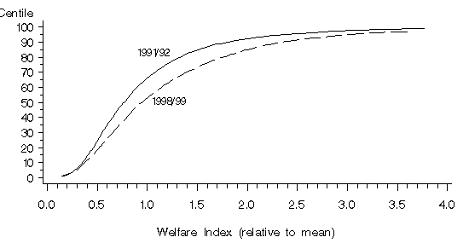Figure 7 : Poverty Incidence Curves, Ghana, 1991/1992 – 1998/1999

Source: Computed from the Ghana Living Standards Survey, 1991/1992 and 1988/1999.

A more sophisticated and thorough assessment of sensitivity to the poverty line would consider a wide range of possible lines. This can be examined using poverty incidence curves (see Box 2). Applying this at the national level (Figure 7) shows that for all reasonable levels of the poverty line, poverty has indeed fallen. The present poverty line corresponds to around 62 percent of the mean value of the standard of living measure in the GLSS 3 distribution (the scale used on the horizontal axis of the figure) and the extreme poverty line to 48 percent. Even for lines somewhat below the extreme poverty line, poverty has fallen between 1991-1992 and 1998-1999.

Box 2: Poverty incidence curves

This is a means of assessing the robustness of poverty comparisons, which may be comparisons between different groups at a point in time or comparisons of the same group at two or more points in time. The poverty incidence curve plots the proportion of the population at different values of y, where y refers to some measure of the standard of living. If such a curve is drawn for two different groups, say group A and group B, then if one curve (say that for A) lies always below that for the other group (B say), then the property of first order dominance is said to hold. This means that poverty is unambiguously lower for group A than for group B, irrespective of where the poverty line is drawn. This conclusion is valid for a wide range of different poverty indices, including all indices in the P_{α} class.

Often the curves will cross, in which case outcomes of poverty comparisons would depend on where the poverty line is drawn relative to the point(s) where the curves cross. In this case, setting the poverty line below a crossing point may give the opposite conclusion about poverty trends to setting it above the crossing point. In these circumstances poverty comparisons may not be robust. It is possible to look for second and higher order dominance in such circumstances, but even where these are found, any unambiguous conclusions about poverty comparisons are only valid for a more restricted class of indices.

Applying the same procedure at the locality level (figures not presented here) shows the same pattern in Accra and the Rural Forest where in fact first order dominance holds. In other words, poverty has fallen in these localities whatever poverty line or poverty measure is used. By contrast the trends in poverty in the Urban Coastal, Urban Savannah and Rural Savannah localities are sensitive to where the poverty line is drawn, with, in both cases, lower poverty lines giving an increase in poverty, even though higher lines would suggest a modest reduction. Something similar is true in Rural Coastal and Urban Forest where the curves are very close at low levels of the standard of living, though here the poverty line would need to be set even below the extreme poverty line for the incidence of poverty to increase.

The use of poverty indices taking account of the depth as well as the incidence of poverty (values of the P_{α} series of indices for α ≥ 1) again gives qualitatively similar patterns and national level trends. Poverty indices which take account of the depth as well as the incidence of poverty do sometimes give different directions of change from those taking account of the incidence alone. For instance, poverty indices allowing for the depth of poverty indicate increases in the Rural Savannah, in contrast to the incidence measure which showed a modest reduction. This outcome though is to be expected given the different trends in the incidence of poverty and extreme poverty in this locality.

In summary, the choice of poverty index or poverty line does not affect the conclusions of this analysis. Many of the main messages are not sensitive to the level at which the poverty line is set or to the particular poverty index used. Poverty at a national level has fallen between 1991-1992 and 1998-1999, with this national fall predominantly reflecting large falls in Accra and the Rural Forest. Poverty in other areas of the country has fallen by much less or even sometimes increased (notably in the Savannah area, the poorest area anyway). Outside of Accra and the Rural Forest extreme poverty has increased in the savannah zone in particular, reflecting an increase in the depth of poverty.

Proximate determinants of poverty change

For a given poverty line, changes in a poverty index can be expressed in terms of the change due to:

- the observed change in the mean value of the standard of living measure, assuming that inequality had remained unchanged ( “growth” effect);

- the observed change in inequality, assuming the mean value had remained unchanged (redistribution effect);

- a residual term, effects not captured in the above (known as the “interactive” term).

Growth in the average standard of living will reduce poverty other things being equal, but where it is accompanied by an increase in inequality, the reduction in poverty will be reduced. The effectiveness of growth in poverty reduction is increased where that growth is pro-poor, in other words when it is accompanied by falling inequality. To what extent do changes in poverty in Ghana reflect changes in the average living standard, and what role have changes in inequality played?

Table 3 presents this decomposition of changes in the incidence of poverty for Ghana and for seven geographic localities. The reduction in the incidence of poverty at the national level and in most localities overwhelmingly reflects the growth in mean consumption; the increases in the incidence of poverty in the Urban Savannah is also predominantly due to the change (reduction here) in mean consumption. At the national level though changes in inequality contribute little to the changes in poverty. But it is important in some localities. Reductions in inequality contribute to the reduction in poverty in Accra and to a lesser extent in the Rural Forest; in several other localities (notably in the Coastal zone and the Rural Savannah) increases in inequality contribute to increases in poverty, so offsetting beneficial growth effects.

Table 3: Decomposition of change in poverty incidence 1991/1992 – 1998/1999, by location
 |  | Share of percentage change due to:
 | Total change | Growth effect | Redistribution effect | Residual
(percent)
Accra | -19.6 | -12.6 | -10.3 | 3.3
Urban Coastal | -3.0 | -11.8 | 8.0 | 0.8
Urban Forest | -8.7 | -11.2 | 0.0 | 2.4
Urban Savannah | 5.5 | 6.5 | -1.7 | 0.6
Rural Coastal | -7.0 | -9.8 | 1.8 | 1.0
Rural Forest | -25.2 | -23.3 | -1.6 | -0.3
Rural Savannah | -2.0 | -5.0 | 1.6 | 1.5
All Ghana | -12.1 | -13.8 | 0.1 | 1.5
Source: Computed from the Ghana Living Standards Survey, 1991/1992 and 1988/1999.

It is of interest that the two localities where substantial poverty reduction occurs, Accra and the Rural Forest, also experience reductions in inequality. Rising inequality then has been evident in those localities which have fared less well in poverty reduction. These localities have experienced little growth in average living standards, and what growth there has been has benefited the non-poor disproportionately.

In summary, where poverty has declined the most, increasing mean consumption and improving consumption inequality have both contributed positively to the poverty decline. Localities experiencing less marked reductions appear to have experienced growing inequality, which has tempered the poverty impact of the already modest growth in mean consumption.

IV. POVERTY IN TERMS OF ASSETS AND HUMAN DEVELOPMENT:

METHODOLOGY

The first part of this report has clearly shown that the incidence of poverty – measured in terms of consumption expenditure – has declined by quite a large margin in Ghana during the 1990s, although this reduction has not been uniformly spread across the country. Most of the decline in the incidence of consumption poverty occurred in Accra and in the rural areas of the Forest ecological zone. Other areas experienced little, if any, reduction in consumption poverty, and in these areas the living conditions of the poorest among the poor often declined.

Of course, poverty is a multi-dimensional phenomenon and consumption-based measures need to be supplemented by other welfare indicators. The following two sections of this report will analyse poverty in terms of household ownership of durable goods and housing characteristics (section V), and address progress in human development by looking at use of health and education facilities (section VI).

Education, health and access to safe water are variables often labelled “basic needs” and should be seen as complementary to the consumption-based welfare indicator. They have some of the characteristics of public goods and are conceptually difficult to measure in monetary terms. The remaining factors can be labelled physical assets and be mainly seen as alternatives to the consumption-based measures of welfare presented in section III. One of the advantages of these asset-based indicators is the ease with which they can be measured compared to indicators based on consumption expenditure.

For each of these non-monetary measures, it is valuable to look at the relationship between the variations in living conditions they reveal and those of the consumption-based standard of living measure. This is considered here based on a division of households into quintile groups reflecting their standard of living according to the consumption-based measure. The lowest quintile group represents the poorest 20% of individuals in the population , the second quintile the next poorest 20% and so on until the highest quintile which contains the richest 20%. These groups are defined at a national level throughout; whenever results are presented by quintile group for urban and rural areas separately, the quintile groups are still those defined at the national level. Therefore for example those in urban areas reported as being in the fifth quintile have comparable living standards to those in the fifth quintile in rural areas.

V. HOUSEHOLD ASSETS AND ACCESS TO SERVICES

Household assets

The GLSS asks households about their ownership of key consumer durable goods. Changes in household ownership of such assets can be considered as an indicator of changing living standards of households. Of course, whether or not a household possesses some of these assets also depends on factors outside the control of households, such as whether or not they have access to electricity. Nonetheless, it can still be thought of as a proxy indicator of the standard of living.

Information on the proportion of households owning different consumer durable goods in 1991-1992 and 1998-1999 is presented in Figures 8 and 9 for urban and rural areas respectively (and also in Tables A2.1, A2.2a and A2.2b in Appendix 2). In both urban and rural areas, the proportion of households owning most of these assets shows large increases over this period, this being especially noticeable for refrigerators, radios, televisions, fans and electric irons. However, with only the exception of bicycles (incidentally mostly owned by households in the savannah), the proportions of households owning these assets remains much higher in urban areas than in rural areas. Most likely this reflects not just higher incomes in urban areas but also supply factors including wider access to electricity.

Further examination reveals that the increases in the proportion of households owning these goods occurs in all geographic localities, including those which displayed little reduction – or even increases – in consumption poverty (see Appendix 2, Table A2.1).

More information can be provided by examining specific durable goods in greater detail. Figures 10 and 11 examine ownership of two such goods, one which is obviously a useful, productive asset for the households (a refrigerator) and another which is a pure consumer good (television). The figures present the changes in ownership of these assets for different quintile groups of households defined according to their standard of living (see section IV).

Ownership of these durable goods is clearly positively correlated with the standard of living, the proportion of households owning these assets increasing sharply with the quintile group. This is observed in both urban and rural areas, and in both years. However, the level of ownership of these assets is much lower in rural areas than among urban households of a comparable standard of living. For instance, ownership of these assets by the highest quintile in rural areas is lower than even among urban households in the third quintile. Lower ownership of these assets in rural areas clearly does not just reflect lower income levels, it probably also reflects supply factors, in other words less opportunity to acquire and/or use such goods (e.g. because of less access to electricity ).

Between 1991-1992 and 1998-1999, increases in the proportions of households owning these durable goods are observed in all quintile groups, apart from the first quintile in urban areas (where the sample is quite small anyway). However, in the higher quintile groups the proportion of households owning these assets increases more than in the lower quintile groups. This is observed in both rural and urban areas, but more dramatically so in urban areas.

These patterns are not unique to the selected assets but are observed for other durable goods as well (see the tables in Appendix 2 for more details).

In summary, the proportions of households owning most durable goods have shown large increases between 1991-1992 and 1998-1999, these increases being observed in both urban and rural areas. Increases though have often been higher for wealthier groups, and ownership of durable goods remains much lower in rural areas than urban areas, even among households of similar overall living standards.

Housing characteristics

Some of the most important housing characteristics concern the facilities to which a household has access. Figures 12 to 14 report the proportion of households having access to potable water, using adequate toilet facilities and having access to electricity respectively (more detail being provided in Appendix 2). As before this is examined separately for urban and rural areas according to the household’s standard of living (again defined by the quintile group it belongs to).

In urban areas, a large majority of households in all quintile groups have access to potable water (defined as non-natural sources), though the proportion still increases with the quintile group. In urban areas these proportions change only modestly between 1991-1992 and 1998-1999, increasing slightly in the top two quintile groups and falling slightly in the lowest three. By contrast, in rural areas there is a much bigger change in the proportion of households having access to potable water, this being especially large for those in the lower quintiles. Indeed, by 1998-1999 around two-thirds of rural households have access to potable water, and this proportion does not vary with the standard of living. This contrasts with 1991-1992 when on average only around one half of rural households had access to potable water, and when this proportion did show an increasing relationship with the standard of living. This represents a large and broadly based change in the proportion of rural households with access to potable water over what is only a seven-year period, so that the urban-rural gap has fallen. More detailed analysis shows that much of the change in rural areas reflects increased use of water from wells and less use of rainwater and water from lakes, rivers etc. These trends are consistent with Government interventions which are focused mainly on improving access for rural areas while encouraging the need to ensure private partnerships in water provision for urban areas.

The proportion of households having access to adequate toilet facilities (a flush toilet or the KVIP toilet) increases sharply between 1991-1992 and 1998-1999, in both urban and rural areas (Figure 13). Further analysis reveals that this increase is predominantly due to large increases in the use of KVIP toilets, this being so in both urban and rural areas. It remains the case though that the proportion of rural households with access to adequate toilet facilities is much less than half that of households with a comparable standard of living in urban areas. Within both urban and rural areas, this proportion increases systematically with the standard of living. Indeed in rural areas this proportion has increased by more in higher quintile groups than in lower quintile groups, reflecting much higher rates of adoption of KVIP toilets by the former compared to the latter (though there are presumably environmental benefits to all from increased use of improved toilet facilities). Recent initiatives by the Government have focused on increasing KVIP access to rural households and communities. These figures suggest that though all groups have benefited, wealthier groups have benefited more.

The proportion of households in urban areas having access to electricity is more than three times that of households with comparable standards of living in rural areas (Figure 14). In addition, within both urban and rural areas this proportion is much higher for households in higher quintile groups than lower groups. Between 1991-1992 and 1998-1999, the proportion of urban households with access to electricity only increased significantly in the two highest quintiles, and actually fell in the two lowest quintiles. By contrast in rural areas, where the overall increase is comparable to that in urban areas, the pattern is a bit more broadly based, with increased access to electricity in each quintile group. The increased access to electricity in rural areas presumably reflects the rural electrification carried out over this period. Nevertheless, it is seen that the increases in the proportion of rural households having access to electricity are somewhat higher among the richest groups there than among the poorer groups. This may partly reflect the geographic areas in which electrification took place.

In summary, there have been significant improvements between 1991-1992 and 1998-1999 in the number of households obtaining their drinking water from a safe source, using adequate toilet facilities and having access to electricity. These improvements have taken place both in urban and rural areas. Increases in use of safe drinking water sources have been most pronounced in rural areas and have been quite broadly based. Improvements in access to electricity and adequate toilet facilities have often been more marked for richer groups than poorer groups.

Figure 8 : Percentage of households owning different household assets – Urban Areas
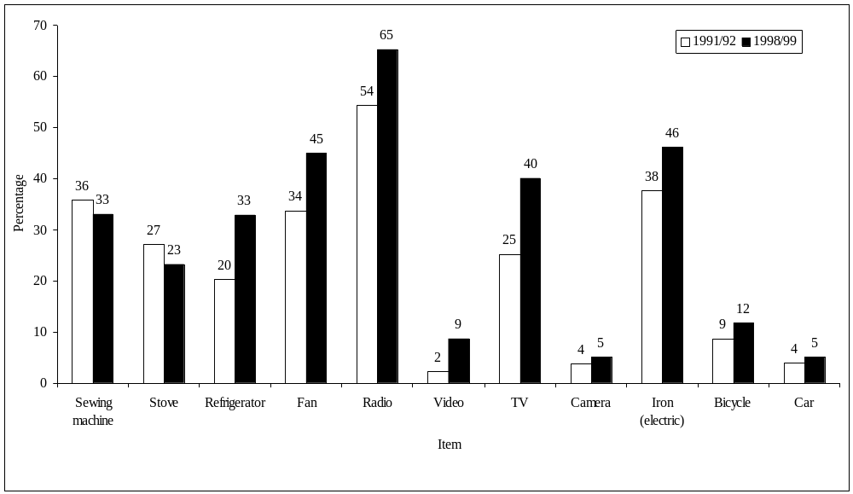
Source : Table A2.2

Figure 9 : Percentage of households owning different household assets – Rural Areas
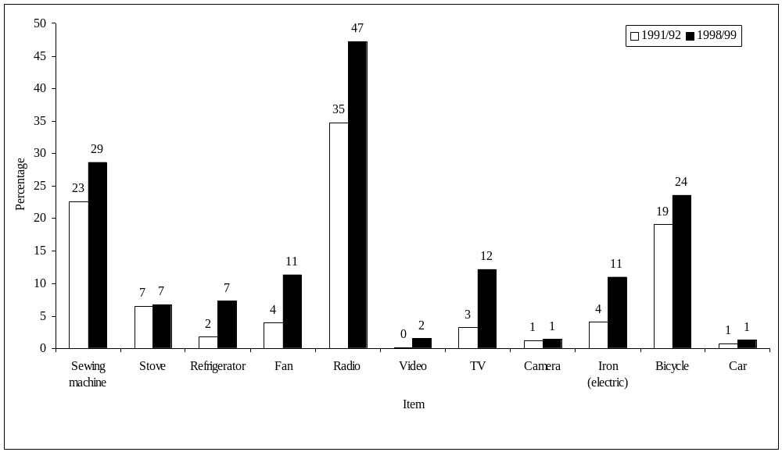
Source : Table A2.2

Figure 10 : Percentage of households owning a Refrigerator, by locality and standard
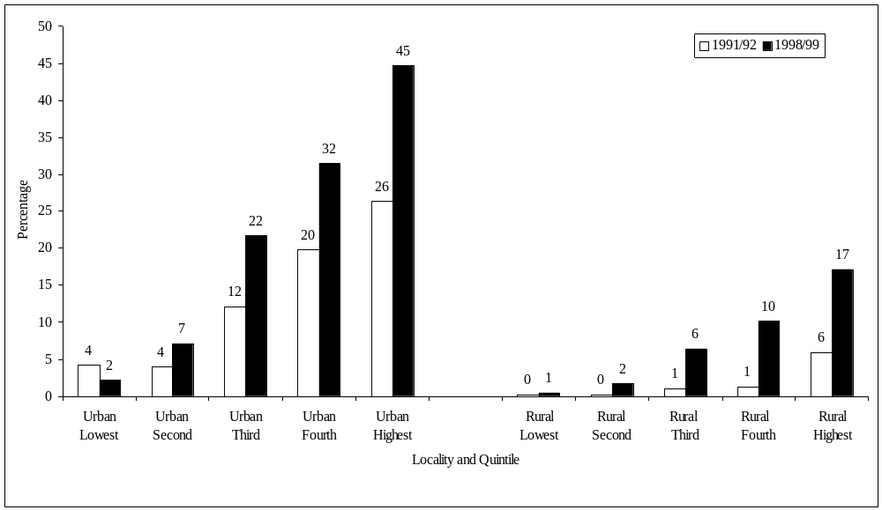
of living quintile

Source : Table A2.2

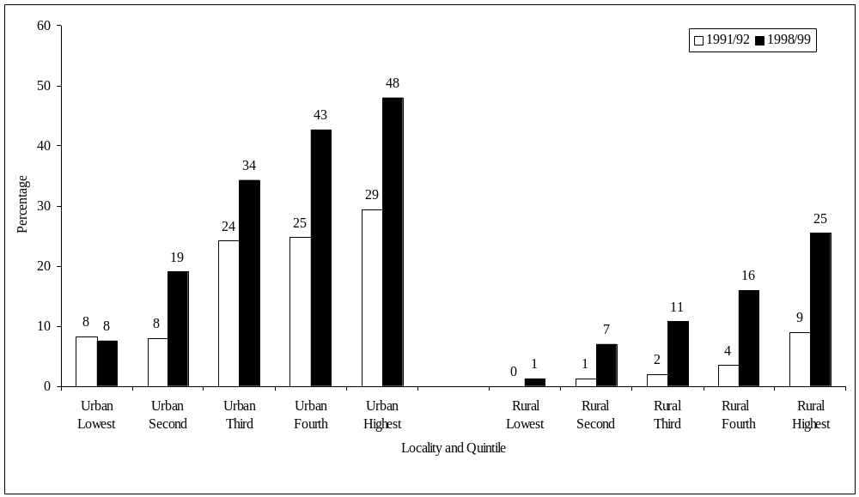
Figure 11: Percentage of households owning a TV, by locality and standard of living quintile

Source : Table A2.2

Figure 12 : Percentage of households having access to potable water, by locality and standard of

living quintile

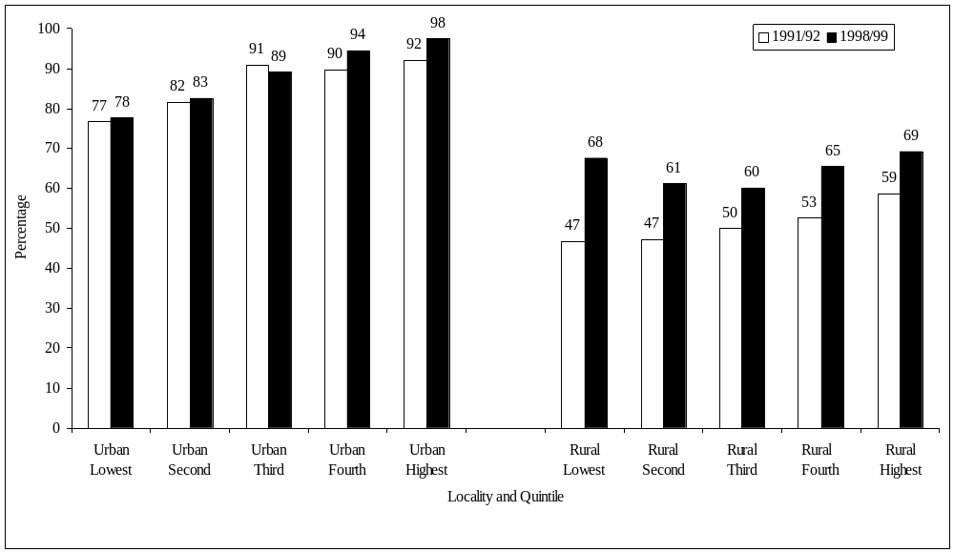
Source : Table A2.3

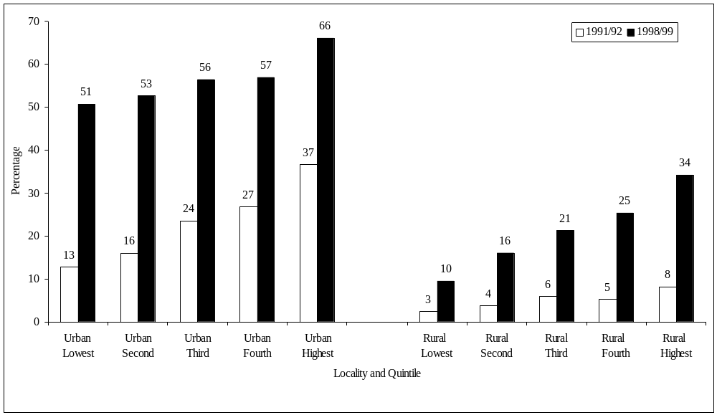
Figure 13 : Percentage of households using a flush or a KVIP toilet, by locality and standard

of living quintile

Source : Table A2.4

Figure 14 : Percentage of households using electricity, by locality and standard of living

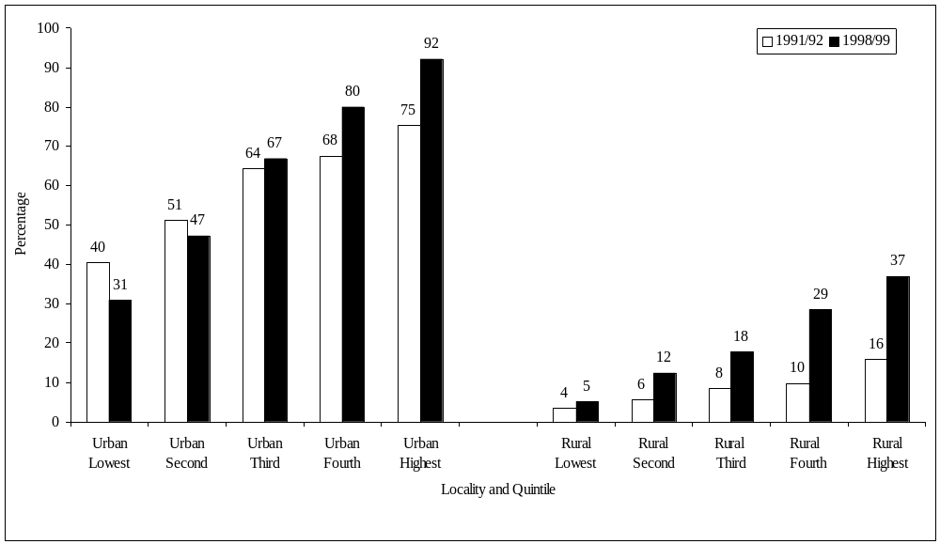
quintile
Source : Table A2.5

VI. HUMAN DEVELOPMENT

Probably the two most important aspects of human development are health and education. The GLSS surveys provide valuable information on the use of health and education facilities, which are examined here by different criteria including geographic locality and the consumption-based standard of living measure (based again on quintile groups at the national level).

Health

The information presented here concerns the use of health facilities by individuals who considered themselves to have been ill or injured in the two weeks preceding the interview. Respondents report themselves whether or not they have been ill or injured, and those who consider that they have are asked about their use of health facilities. Self-diagnosis of illness or injury is inevitably subjective, so that it is not appropriate to focus on prevalence of illness or injury defined in this way. This however, is the appropriate filter question for identifying those who should be asked about their use of health facilities when they are ill or injured.

A first issue is the extent to which the ill or injured consult well-qualified health personnel. Figure 15 reports the proportion of those ill or injured who consulted a doctor or pharmacist, examining how this varies with the standard of living within urban and rural areas. The proportions are much higher in urban areas than rural areas, even within the same quintile groups. In rural areas the proportion who consult a doctor or pharmacist increases systematically with the standard of living, with the proportions in the highest quintile being twice as high as in the lowest quintile in 1991-1992, and three times as high in 1998-1999. In all quintiles however, the proportion of the ill or injured consulting a doctor or pharmacist falls sharply between 1991-1992 and 1998-1999. In urban areas the proportions that consult a doctor or pharmacist is also higher for richer households than poorer. But in contrast to rural areas, the proportion of individuals in urban areas consulting a doctor or pharmacist only falls significantly between 1991-1992 and 1998-1999 in the lowest three quintiles, actually remaining unchanged or increasing slightly in the two highest quintiles.
The reductions (richer urban groups excepted) over this time period in the proportions consulting a doctor or pharmacist, or attending a hospital, would be less worrying if there was evidence that the reduction reflected more appropriate consultation behaviour by those who are ill. For example, if people with less serious medical conditions were now consulting a nurse or medical assistant where they had previously – unnecessarily – consulted a doctor (or using a clinic rather than a hospital) then this could represent a more rational allocation of resources. Unfortunately this is not predominantly the explanation for the change (Tables A3.1a and A3.1b in Appendix 3). While it is true that in urban areas the number of ill or injured consulting a nurse or midwife has increased slightly, there has been a large increase in the proportion not consulting at all. In rural areas the proportion consulting a medical assistant has increased marginally, but there is a much larger increase in the proportion not consulting anyone at all. Further investigation is obviously required, but these are clearly very worrying developments from the point of view of health policy.

Figure 16 reports the percentage of those who were ill or injured that consulted in a hospital. For both urban and rural areas, the patterns are very similar to those of Figure 15. In rural areas, within each year the proportions consulting in a hospital increase markedly with the standard of living quintile. In urban areas this proportion also increases overall with the standard of living quintile, though the relationship is less strong. Between 1991-1992 and 1998-1999, the proportion in rural areas who consult in a hospital falls in all quintile groups; in urban areas it falls only in the second quintile. Again the reduction in the use of hospitals in rural areas happens simultaneously with an increase in the proportion not consulting at all (Table A3.2b, Appendix 3). The same phenomenon is observed among the urban poor, specifically in the first two quintiles in urban areas (Table A3.2a, Appendix 3).

These findings are consistent with the information available from other sources. It is a well accepted fact that the introduction of user fees in the late 1980s substantially reduced health facility use. In addition, increased costs were not matched with increased quality. In this context, the recent health sector investment programme undertaken by the Government recognizes the need to improve quality of and access to health facilities throughout the country. These results indicate that this is a very important priority.

In summary, compared to 1991-1992, Ghanaians are less likely now to consult well-qualified health personnel, or to go to a hospital when they are ill or injured. Increasing numbers are not consulting anyone at all. This pattern is observed in all income groups in rural areas, and in all except the wealthiest groups in urban areas.

Education

A series of education indicators can be considered in examining living standards of the population. However, some of these are more suitable than others when the focus is on changes in living standards and poverty, as here. Variables such as illiteracy rates and education level of the whole population will only change gradually over time, and mainly only to the extent that school enrolments change. For this reason, given the focus on change over time, school enrolment rates at primary and secondary levels are the most appropriate variables to examine here. To the extent that these are increasing over time, literacy rates and rates of educational attainment for the whole population will increase as well, though more gradually.

Attendance of children at primary and secondary school are examined in terms of net enrolment rates, that is the percentage of those in the relevant age range attending primary or secondary school. At primary level (Figures 17 and 18, also Appendix 3), net enrolment rates at the national level increased from around 74% in 1991-1992 to 83% in 1998-1999, a quite large increase over a seven year period. The net enrolment rate for girls is slightly below that for boys, though the rates for both boys and girls show similar patterns of increase over this period.

Net enrolment rates in primary school do not vary dramatically by geographic locality, except in the Rural Savannah where net enrolment rates are much lower than elsewhere. In each of the localities identified in Figure 17, net enrolment rates in primary increase between 1991-1992 and 1998-1999, with the biggest increases occurring in the savannah zone (rural and urban). In each locality also net enrolment rates for girls are a few percentage points below those for boys, except in the coastal zone (urban and rural) in 1998-1999, where girls have a slight advantage.

For both boys and girls, net enrolment rates in primary school increase with the standard of living (Figure 18). Net enrolment rates however increase slightly faster between 1991-1992 and 1998-1999 among the poorer groups than among the richer groups, so that the differential between rates for the richer and poorer groups has reduced over this period. This is true in both urban and rural areas; in both cases this partly reflects the faster growth of school attendance in the savannah zone (which is poorer on average) than elsewhere. In each of the quintile groups the net enrolment rates for girls are slightly below those for boys, suggesting that this gender differential is not primarily a reflection of poverty.

Net enrolment rates in secondary school are much lower than those for primary school (Figures 19 and 20, and Appendix 3). In 1998-1999 the net enrolment rate at secondary school was only 40.7%, less than half that at the primary level (83.4%). A more pronounced urban-rural differential is apparent at secondary level than at the primary level, in favour of urban areas.

Net enrolment rates for boys are higher than for girls at the secondary level, but the extent of this has fallen sharply between 1991-1992 and 1998-1999. Over this period net enrolment rates for girls increased by 6% at the national level, with increases in all localities but Rural Savannah, by large magnitudes in some areas (e.g. Accra, Rural Coastal). Over the same period net enrolment rates for boys increased much less, and net enrolment rates for boys fell in both urban and rural areas of the coastal zone, and in other rural areas. By 1998-1999 the gender differential in net enrolment rates at secondary school is similar in magnitude to that for primary school, suggesting that there may now be no additional discrimination against girls at the secondary level compared to that observed at the primary level.

As at the primary level, net enrolment rates for primary school, at national level, increase with the standard of living, but even among the richest twenty percent only one in two children of secondary school age is actually attending secondary school. Net enrolment rates of girls in secondary school increase between 1991-1992 and 1998-1999 in all quintile groups except the lowest; a similar pattern is observed for boys, but the magnitude of change is smaller, except in the highest quintile. As at the primary level the differential between boys and girls in enrolment rates is not strongly associated with the standard of living, that for girls being lower in all quintile groups.

In summary, enrolment rates in primary and secondary school have improved quite sharply over the seven year period considered here. Now more than four out of five Ghanaian children in the relevant age group are attending primary school. Enrolment rates in the savannah are growing faster than elsewhere, though still remain low in the Rural Savannah. The increases in net enrolment rates at secondary level have been much bigger for girls than boys, but even still rates for girls remain below those for boys. Even with these increases, net enrolment rates at secondary level are much lower than at primary level, especially so in rural areas.

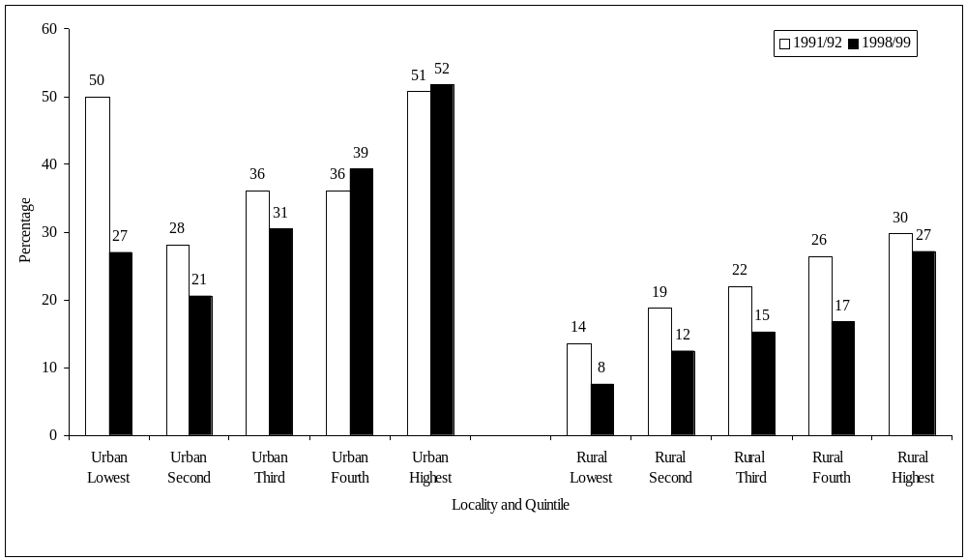
Figure 15 : Percentage of ill or injured individuals that consulted a doctor or a
pharmacist, by locality and standard of living quintile
Source : Table A3.1

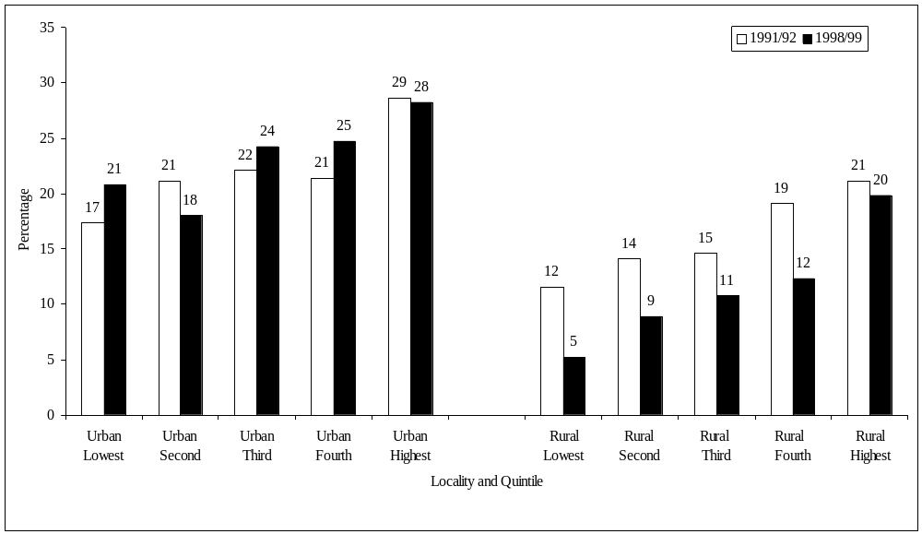
Figure 16 : Percentage of ill or injured individuals that went to hospital, by locality
and standard of living quintile
Source : Table A3.2

Figure 17 : Net enrolment rates in primary school, by gender and locality

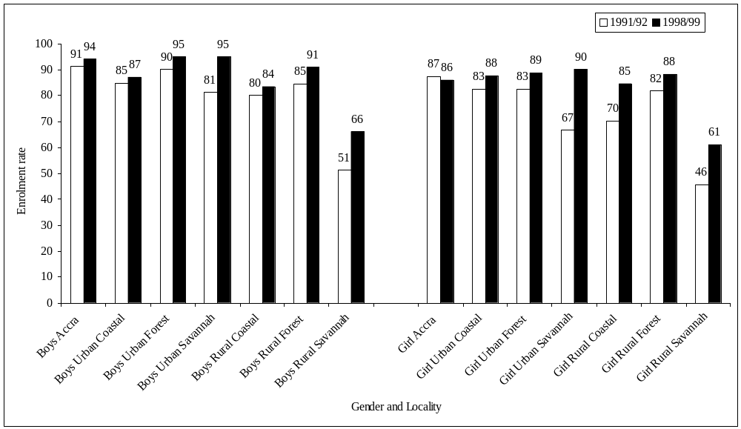
Source : Table A3.3

Figure 18 : Net enrolment rates in primary school, by gender and standard of living quintile
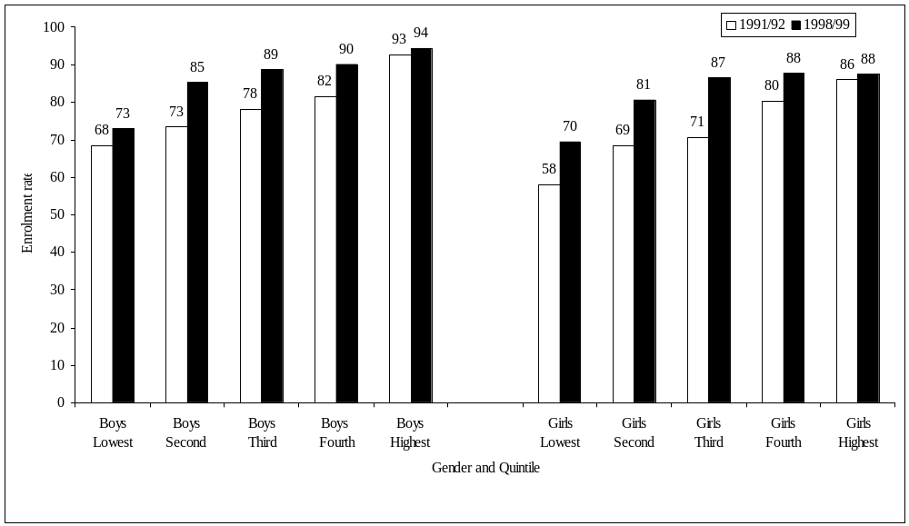
Source : Table A3.3

Figure 19 : Net enrolment rates in secondary school, by gender and locality

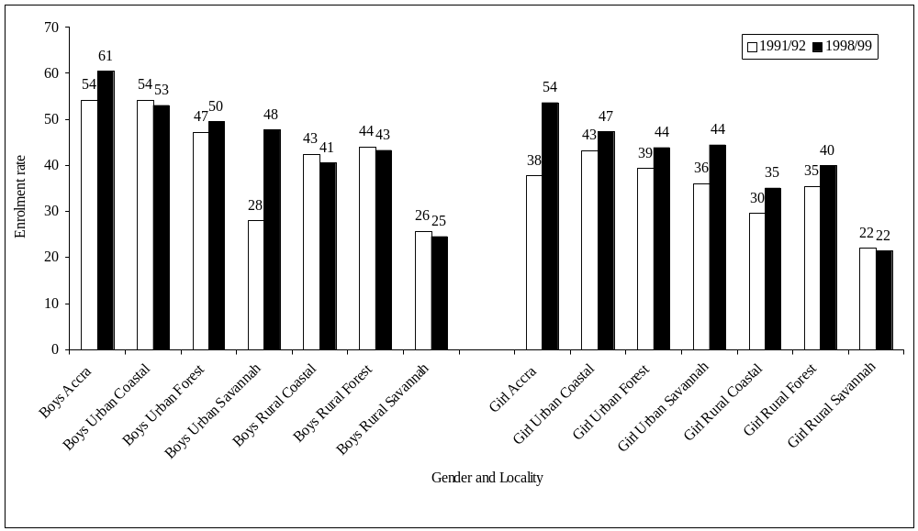
Source : Table A3.4

Figure 20 : Net enrolment rates in secondary school, by gender and standard of living quintile
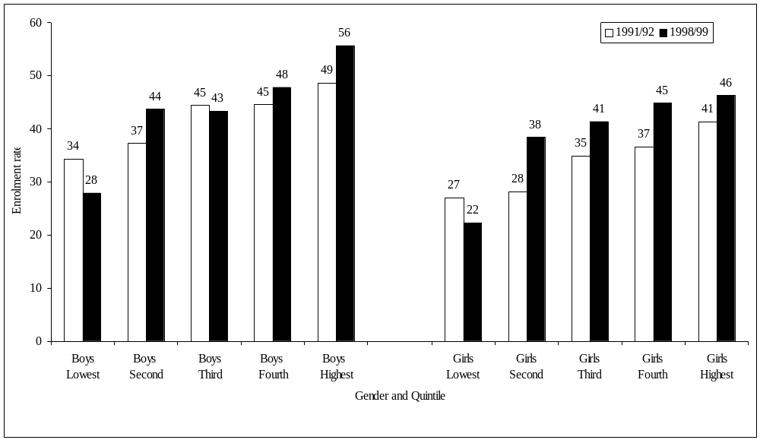
Source : Table A3.4

VII. CONCLUDING OBSERVATIONS

The fourth round of the Ghana Living Standards Survey conducted in 1998-1999 represents a rich source of data on the many different aspects of living conditions of households. These data are comparable with those collected during the third round in 1991-1992. These two data sets make it possible to examine the changes of poverty in Ghana over the 1990s. This report examines poverty by looking at three different dimensions: consumption poverty; poverty in terms of assets and housing facilities; and human development.

There are many similarities and some important differences in the trends revealed by these three different approaches. At the national level the incidence of consumption poverty has fallen by 12.2 percent over this seven-year period. This reduction in consumption poverty has been uneven geographically, with Accra and the forest ecological zone posting the highest declines. In some areas poverty has fallen only very marginally, or has even increased. In some of these areas, notably in the Rural Savannah, the situation of the very poorest has worsened. These same areas have experienced increasing inequality, offsetting the poverty reducing effects of any growth in average living standards that has taken place. Large poverty reductions have occurred among private sector employees in both the formal and informal sectors, and among public sector wage employees, but the largest reduction in consumption poverty has been experienced by export farmers. Poverty reduction among the large numbers of food crop farmers on the other hand has been smaller.

Household ownership of durable goods, and access to safe drinking water, adequate toilet facilities and electricity have all increased over this period. These changes have been observed in most income groups and areas of the country, though in many cases the gains have not been equally distributed, with richer groups usually benefiting more.

Primary school enrolments have increased by nearly ten percentage points over this period, with the biggest increases in the savannah and rural areas. Secondary school enrolments are much lower and have increased by less. The enrolment rates for girls increased more than for boys.

The picture in terms of use of the use of health facilities is somewhat less positive. There has been a discernible decline in the number of individuals seeking modern medical care following an illness or injury. There has been a significant increase in the proportion of the sick who seek no form of outside medical advice or care. The reasons for these changes clearly need further and urgent investigation.

Apart from the use of health services, most of the indicators in the GLSS suggest an improvement in the living standards of Ghanaians. At the national level, the indicators all point to long term progress in Ghana (higher school enrolments, better access to safe drinking water, and so on). At the same time, the evidence indicates that the benefits of this have not been enjoyed, or have been enjoyed much less, by the poorest groups (food farmers, those in the Rural Savannah). The indicators (both monetary and non-monetary) also serve to remind us of the persistent inequalities in Ghanaian society. These are more pronounced in rural areas in general and the savannah in particular. Food producing farmers, especially in the northern regions, deserve particular policy attention.

References

Appiah, Kweku, S., George Laryea-Adjei and Lionel Demery (1999), “Poverty Past and Present in Ghana”, (mimeo., World Bank, Washington D.C.).

Coulombe, Harold and Andrew McKay (2000) “Assessing the Robustness of Changes in Poverty in Ghana Over the 1990s”, (mimeo, World Bank, Washington, D.C., and GSS, Accra, Ghana).

Ghana Statistical Service (1995), The Pattern of Poverty in Ghana, 1988-1992 (GSS, Accra, Ghana).

National Research Council, Sub-Committee of the 10th Editions of the RDAs (1989), Recommended Dietary Allowances (Washington D.C.: National Academy Press, 1989).

Platt B. (1962), Tables of Representative values of foods commonly used in Tropical Countries, Medical Research Council Special Report no. 253, H.M. Stationary Office, London.

Ravallion, M. and B. Bidani (1994), “How Robust is a Poverty Profile?”, World Bank Economic Review, Vol. 8, No. 1, pp.75-102.

Scott, C. and B. Amenuvegbe (1990), “Effect of Recall Duration on Reporting of Household Expenditures: An Experimental Study in Ghana”, Social Dimensions of Adjustment Working Paper No. 6, World Bank, Washington D.C.

Scott, C. and B. Amenuvegbe (1991), “Reconciling fixed interview workloads with self-weighting sampling when size measures are defective”, Journal of Official Statistics, Vol. 7, No. 3, pp. 367-373.

World Bank (1995), Ghana: Poverty Past, Present and Future, Report No. 14504-GH, June 29, World Bank, Washington D.C.

APPENDIX 1: MAIN TABLES - CONSUMPTION POVERTY INDICES

Table A1.1: Indices of extreme poverty by location, 1991/1992 and 1998/1999
Poverty line = 700,000 cedis

1991/1992
 |  |  | Poverty indices |  |  |  |  | Contribution to national poverty
 | Pop’n share | Average  Welfare | P₀ | P₁ | P₂ | P₁/P₀ |  | C₀ | C₁ | C₂
Accra | 8.2 | 1844.8 | 0.113 | 0.020 | 0.005 | 0.175 |  | 2.5 | 1.5 | 0.9
Urban Coastal | 8.7 | 1433.6 | 0.142 | 0.027 | 0.008 | 0.194 |  | 3.4 | 2.2 | 1.4
Urban Forest | 11.0 | 1618.9 | 0.129 | 0.026 | 0.007 | 0.200 |  | 3.9 | 2.5 | 1.7
Urban Savannah | 5.3 | 1321.2 | 0.270 | 0.084 | 0.042 | 0.311 |  | 3.9 | 4.0 | 4.8
Rural Coastal | 14.2 | 1085.5 | 0.328 | 0.084 | 0.030 | 0.257 |  | 12.7 | 10.8 | 9.0
Rural Forest | 29.6 | 938.0 | 0.459 | 0.136 | 0.055 | 0.296 |  | 37.3 | 36.5 | 34.3
Rural Savannah | 23.1 | 762.9 | 0.575 | 0.204 | 0.098 | 0.354 |  | 36.3 | 42.6 | 48.0
All | 100.0 | 1130.8 | 0.365 | 0.111 | 0.047 | 0.303 |  | 100.0 | 100.0 | 100.0
Source: Computed from the Ghana Living Standards Survey, 1991/1992.

1998/1999
 |  |  | Poverty indices |  |  |  |  | Contribution to national poverty
 | Pop’n share | Average  welfare | P₀ | P₁ | P₂ | P₁/P₀ |  | C₀ | C₁ | C₂
Accra | 8.8 | 2468.5 | 0.017 | 0.003 | 0.001 | 0.161 |  | 0.6 | 0.3 | 0.2
Urban Coastal | 7.8 | 1769.9 | 0.143 | 0.034 | 0.013 | 0.240 |  | 4.2 | 3.2 | 2.8
Urban Forest | 11.8 | 2005.0 | 0.109 | 0.025 | 0.009 | 0.229 |  | 4.8 | 3.5 | 2.8
Urban Savannah | 4.8 | 1191.6 | 0.271 | 0.051 | 0.015 | 0.188 |  | 4.9 | 3.0 | 2.0
Rural Coastal | 14.6 | 1248.3 | 0.282 | 0.076 | 0.029 | 0.269 |  | 15.3 | 13.3 | 11.6
Rural Forest | 31.6 | 1297.9 | 0.211 | 0.053 | 0.020 | 0.249 |  | 24.8 | 19.9 | 17.4
Rural Savannah | 20.6 | 826.8 | 0.593 | 0.230 | 0.111 | 0.388 |  | 45.5 | 56.9 | 63.3
All | 100.0 | 1412.1 | 0.268 | 0.083 | 0.036 | 0.310 |  | 100.0 | 100.0 | 100.0
Source: Computed from the Ghana Living Standards Survey, 1998/1999.

Notes : Pop’n share is expressed in percent, and ‘average welfare’ denotes the mean value of the standard of living measure,
expressed in thousands of cedis. P₀, P₁, P₂ denote values of the P_{α} (extreme) poverty indices for α=0, 1, 2 respectively; C₀, C₁, C₂ is the
percentage contribution of each group to national extreme poverty as defined by P₀, P₁, P₂ respectively; and P₁/P₀ is the income gap
ratio for the extreme poverty line: the average proportion by which the extreme poor fall below the extreme poverty line.

Table A1.2: Indices of poverty by location, 1991/1992 and 1998/1999
Poverty line = 900,000 cedis

1991/1992
 |  |  | Poverty indices |  |  |  |  | Contribution to national poverty
 | Pop’n share | Average  welfare | P₀ | P₁ | P₂ | P₁/P₀ |  | C₀ | C₁ | C₂
Accra | 8.2 | 1844.8 | 0.231 | 0.051 | 0.017 | 0.219 |  | 3.7 | 2.2 | 1.6
Urban Coastal | 8.7 | 1433.6 | 0.283 | 0.070 | 0.024 | 0.246 |  | 4.7 | 3.3 | 2.3
Urban Forest | 11.0 | 1618.9 | 0.258 | 0.064 | 0.022 | 0.249 |  | 5.5 | 3.8 | 2.8
Urban Savannah | 5.3 | 1321.2 | 0.378 | 0.136 | 0.069 | 0.359 |  | 3.9 | 3.9 | 4.2
Rural Coastal | 14.2 | 1085.5 | 0.525 | 0.161 | 0.067 | 0.306 |  | 14.4 | 12.3 | 10.8
Rural Forest | 29.6 | 938.0 | 0.616 | 0.227 | 0.106 | 0.369 |  | 35.3 | 36.4 | 35.8
Rural Savannah | 23.1 | 762.9 | 0.730 | 0.305 | 0.161 | 0.418 |  | 32.6 | 38.1 | 42.5
All | 100.0 | 1130.8 | 0.517 | 0.185 | 0.088 | 0.357 |  | 100.0 | 100.0 | 100.0
Source: Computed from the Ghana Living Standards Survey, 1991/1992.

1998/1999
 |  |  | Poverty indices |  |  |  |  | Contribution to national poverty
 | Pop’n share | Average  welfare | P₀ | P₁ | P₂ | P₁/P₀ |  | C₀ | C₁ | C₂
Accra | 8.8 | 2468.5 | 0.038 | 0.008 | 0.002 | 0.208 |  | 0.8 | 0.5 | 0.3
Urban Coastal | 7.8 | 1769.9 | 0.242 | 0.070 | 0.028 | 0.288 |  | 4.8 | 3.9 | 3.4
Urban Forest | 11.8 | 2005.0 | 0.182 | 0.051 | 0.020 | 0.281 |  | 5.4 | 4.3 | 3.6
Urban Savannah | 4.8 | 1191.6 | 0.430 | 0.114 | 0.042 | 0.265 |  | 5.2 | 4.0 | 3.1
Rural Coastal | 14.6 | 1248.3 | 0.452 | 0.141 | 0.061 | 0.312 |  | 16.7 | 14.8 | 13.3
Rural Forest | 31.6 | 1297.9 | 0.380 | 0.107 | 0.044 | 0.283 |  | 30.4 | 24.4 | 20.8
Rural Savannah | 20.6 | 826.8 | 0.700 | 0.323 | 0.178 | 0.462 |  | 36.6 | 48.0 | 55.5
All | 100.0 | 1412.1 | 0.395 | 0.139 | 0.066 | 0.352 |  | 100.0 | 100.0 | 100.0
Source: Computed from the Ghana Living Standards Survey, 1998/1999.

Notes: Pop’n share is expressed in percent, and ‘average welfare’ denotes the mean value of the standard of living measure,
expressed in thousands of cedis. P₀, P₁, P₂ denote values of the P_{α} poverty indices for α=0, 1, 2 respectively; C₀, C₁, C₂ is the
percentage contribution of each group to national poverty as defined by P₀, P₁, P₂ respectively; and P₁/P₀ is the income gap
ratio for the poverty line: the average proportion by which the poor fall below the poverty line.

Table A1.3: Indices of extreme poverty by main economic activity, 1991/1992 and 1998/1999
Poverty line 700,000 cedis

1991/1992
 |  |  | Poverty indices |  |  |  |  | Contribution to national poverty
 | Pop’n share | Average  welfare | P₀ | P₁ | P₂ | P₁/P₀ |  | C₀ | C₁ | C₂
Public sector empl. | 13.5 | 1470.3 | 0.212 | 0.053 | 0.020 | 0.249 |  | 7.9 | 6.5 | 5.6
Private formal empl. | 3.9 | 1523.8 | 0.151 | 0.037 | 0.016 | 0.242 |  | 1.6 | 1.3 | 1.3
Private informal empl. | 3.1 | 1376.9 | 0.225 | 0.053 | 0.019 | 0.235 |  | 1.9 | 1.5 | 1.2
Export farmers | 6.3 | 886.4 | 0.496 | 0.154 | 0.067 | 0.310 |  | 8.5 | 8.7 | 8.8
Food crop farmers | 43.6 | 837.9 | 0.518 | 0.171 | 0.077 | 0.331 |  | 61.7 | 67.5 | 70.7
Non-farm self empl. | 27.6 | 1348.7 | 0.233 | 0.056 | 0.020 | 0.241 |  | 17.7 | 14.0 | 11.9
Non-working | 2.0 | 1829.1 | 0.130 | 0.027 | 0.008 | 0.204 |  | 0.7 | 0.5 | 0.3
All | 100.0 | 1130.8 | 0.365 | 0.111 | 0.047 | 0.303 |  | 100.0 | 100.0 | 100.0
Source: Computed from the Ghana Living Standards Survey, 1991/1992.

1998/1999
 |  |  | Poverty indices |  |  |  |  | Contribution to national poverty
 | Pop’n share | Average  welfare | P₀ | P₁ | P₂ | P₁/P₀ |  | C₀ | C₁ | C₂
Public sector empl. | 10.7 | 1773.6 | 0.095 | 0.019 | 0.006 | 0.201 |  | 3.8 | 2.5 | 1.7
Private formal empl. | 4.9 | 2211.5 | 0.045 | 0.007 | 0.001 | 0.153 |  | 0.8 | 0.4 | 0.2
Private informal empl. | 2.9 | 1631.6 | 0.161 | 0.037 | 0.014 | 0.231 |  | 1.7 | 1.3 | 1.1
Export farmers | 7.0 | 1234.4 | 0.194 | 0.046 | 0.017 | 0.236 |  | 5.1 | 3.9 | 3.2
Food crop farmers | 38.6 | 964.0 | 0.450 | 0.159 | 0.073 | 0.353 |  | 64.6 | 73.4 | 78.0
Non-farm self empl. | 33.8 | 1644.4 | 0.181 | 0.043 | 0.016 | 0.237 |  | 22.8 | 17.4 | 14.8
Non-working | 2.1 | 2485.2 | 0.151 | 0.044 | 0.019 | 0.287 |  | 1.2 | 1.1 | 1.1
All | 100.0 | 1412.1 | 0.268 | 0.083 | 0.036 | 0.310 |  | 100.0 | 100.0 | 100.0
Source: Computed from the Ghana Living Standards Survey, 1988/1999.

Notes : as Table A1.1.

Table A1.4: Indices of poverty by main economic activity, 1991/1992 and 1998/1999
Poverty line 900,000 cedis

1991/1992
 |  |  | Poverty indices |  |  |  |  | Contribution to national poverty
 | Pop’n share | Average  welfare | P₀ | P₁ | P₂ | P₁/P₀ |  | C₀ | C₁ | C₂
Public sector empl. | 13.5 | 1470.3 | 0.347 | 0.102 | 0.043 | 0.295 |  | 9.1 | 7.5 | 6.6
Private formal empl. | 3.9 | 1523.8 | 0.303 | 0.077 | 0.032 | 0.256 |  | 2.3 | 1.7 | 1.4
Private informal empl. | 3.1 | 1376.9 | 0.386 | 0.108 | 0.043 | 0.280 |  | 2.3 | 1.8 | 1.5
Export farmers | 6.3 | 886.4 | 0.640 | 0.245 | 0.120 | 0.382 |  | 7.8 | 8.3 | 8.6
Food crop farmers | 43.6 | 837.9 | 0.681 | 0.268 | 0.134 | 0.394 |  | 57.3 | 63.2 | 66.9
Non-farm self empl. | 27.6 | 1348.7 | 0.384 | 0.113 | 0.046 | 0.295 |  | 20.5 | 16.9 | 14.5
Non-working | 2.0 | 1829.1 | 0.188 | 0.054 | 0.021 | 0.287 |  | 0.7 | 0.6 | 0.5
All | 100.0 | 1130.8 | 0.517 | 0.185 | 0.088 | 0.357 |  | 100.0 | 100.0 | 100.0
Source: Computed from the Ghana Living Standards Survey, 1991/1992.

1998/1999
 |  |  | Poverty indices |  |  |  |  | Contribution to national poverty
 | Pop’n share | Average  welfare | P₀ | P₁ | P₂ | P₁/P₀ |  | C₀ | C₁ | C₂
Public sector empl. | 10.7 | 1773.6 | 0.227 | 0.048 | 0.016 | 0.212 |  | 6.2 | 3.7 | 2.6
Private formal empl. | 4.9 | 2211.5 | 0.113 | 0.024 | 0.007 | 0.214 |  | 1.4 | 0.9 | 0.5
Private informal empl. | 2.9 | 1631.6 | 0.252 | 0.074 | 0.030 | 0.294 |  | 1.9 | 1.6 | 1.3
Export farmers | 7.0 | 1234.4 | 0.387 | 0.103 | 0.039 | 0.266 |  | 6.9 | 5.2 | 4.2
Food crop farmers | 38.6 | 964.0 | 0.594 | 0.240 | 0.124 | 0.404 |  | 58.1 | 66.7 | 72.2
Non-farm self empl. | 33.8 | 1644.4 | 0.286 | 0.086 | 0.035 | 0.300 |  | 24.5 | 20.8 | 18.0
Non-working | 2.1 | 2485.2 | 0.204 | 0.074 | 0.035 | 0.365 |  | 1.1 | 1.1 | 1.1
All | 100.0 | 1412.1 | 0.395 | 0.139 | 0.066 | 0.352 |  | 100.0 | 100.0 | 100.0
Source: Computed from the Ghana Living Standards Survey, 1988/1999.

Notes: as Table A1.2.
Table A1.5: Indices of extreme poverty by region, 1991/1992 and 1998/1999
Poverty line = 700,000 cedis

1991/1992
 |  |  | Poverty indices |  |  |  |  | Contribution to national poverty
 | Pop’n share | Average  welfare | P₀ | P₁ | P₂ | P₁/P₀ |  | C₀ | C₁ | C₂
Western | 10.2 | 966.2 | 0.420 | 0.116 | 0.044 | 0.276 |  | 11.7 | 10.6 | 9.5
Central | 10.4 | 1223.1 | 0.241 | 0.070 | 0.030 | 0.291 |  | 6.8 | 6.6 | 6.5
Greater Accra | 11.7 | 1696.0 | 0.134 | 0.028 | 0.009 | 0.211 |  | 4.3 | 3.0 | 2.2
Eastern | 12.9 | 1105.3 | 0.348 | 0.084 | 0.029 | 0.240 |  | 12.3 | 9.8 | 7.8
Volta | 9.0 | 1008.5 | 0.421 | 0.117 | 0.045 | 0.277 |  | 10.4 | 9.5 | 8.5
Ashanti | 15.9 | 1342.3 | 0.255 | 0.069 | 0.027 | 0.272 |  | 11.1 | 9.9 | 9.0
Brong Ahafo | 11.8 | 957.5 | 0.459 | 0.130 | 0.051 | 0.284 |  | 14.9 | 14.0 | 12.7
Northern | 9.5 | 880.6 | 0.541 | 0.214 | 0.114 | 0.395 |  | 14.0 | 18.3 | 22.9
Upper West | 3.1 | 597.1 | 0.743 | 0.299 | 0.151 | 0.403 |  | 6.4 | 8.5 | 10.0
Upper East | 5.6 | 823.2 | 0.535 | 0.194 | 0.092 | 0.363 |  | 8.2 | 9.8 | 10.9
All | 100.0 | 1130.8 | 0.365 | 0.111 | 0.047 | 0.303 |  | 100.0 | 100.0 | 100.0
Source: Computed from the Ghana Living Standards Survey, 1991/1992.

1998/1999
 |  |  | Poverty indices |  |  |  |  | Contribution to national poverty
 | Pop’n share | Average  welfare | P₀ | P₁ | P₂ | P₁/P₀ |  | C₀ | C₁ | C₂
Western | 11.6 | 1503.2 | 0.136 | 0.027 | 0.009 | 0.201 |  | 5.9 | 3.8 | 2.8
Central | 8.9 | 1158.8 | 0.315 | 0.076 | 0.026 | 0.242 |  | 10.5 | 8.2 | 6.4
Greater Accra | 11.9 | 2432.9 | 0.024 | 0.003 | 0.001 | 0.143 |  | 1.1 | 0.5 | 0.2
Eastern | 11.6 | 1188.1 | 0.304 | 0.094 | 0.041 | 0.309 |  | 13.2 | 13.2 | 13.0
Volta | 12.4 | 1260.2 | 0.204 | 0.046 | 0.016 | 0.225 |  | 9.5 | 6.9 | 5.6
Ashanti | 16.8 | 1775.8 | 0.164 | 0.046 | 0.018 | 0.278 |  | 10.3 | 9.2 | 8.5
Brong Ahafo | 8.7 | 1355.5 | 0.188 | 0.045 | 0.018 | 0.241 |  | 6.1 | 4.7 | 4.3
Northern | 10.2 | 866.7 | 0.574 | 0.202 | 0.090 | 0.352 |  | 21.9 | 24.8 | 25.3
Upper West | 3.2 | 604.5 | 0.683 | 0.289 | 0.152 | 0.423 |  | 8.2 | 11.2 | 13.6
Upper East | 4.5 | 562.7 | 0.796 | 0.324 | 0.163 | 0.407 |  | 13.4 | 17.6 | 20.3
All | 100.0 | 1412.1 | 0.268 | 0.083 | 0.036 | 0.310 |  | 100.0 | 100.0 | 100.0
Source: Computed from the Ghana Living Standards Survey, 1998/1999.

Notes: as Table A1.1.

Table A1.6: Indices of poverty by region, 1991/1992 and 1998/1999
Poverty line = 900,000 cedis

1991/1992
 |  |  | Poverty indices |  |  |  |  | Contribution to national poverty
 | Pop’n share | Average  welfare | P₀ | P₁ | P₂ | P₁/P₀ |  | C₀ | C₁ | C₂
Western | 10.2 | 966.2 | 0.596 | 0.205 | 0.091 | 0.344 |  | 11.7 | 11.3 | 10.5
Central | 10.4 | 1223.1 | 0.443 | 0.129 | 0.057 | 0.292 |  | 8.9 | 7.3 | 6.8
Greater Accra | 11.7 | 1696.0 | 0.258 | 0.063 | 0.023 | 0.245 |  | 5.8 | 4.0 | 3.1
Eastern | 12.9 | 1105.3 | 0.480 | 0.159 | 0.066 | 0.331 |  | 12.0 | 11.1 | 9.7
Volta | 9.0 | 1008.5 | 0.570 | 0.201 | 0.091 | 0.352 |  | 9.9 | 9.7 | 9.3
Ashanti | 15.9 | 1342.3 | 0.412 | 0.129 | 0.056 | 0.313 |  | 12.6 | 11.1 | 10.1
Brong Ahafo | 11.8 | 957.5 | 0.650 | 0.228 | 0.102 | 0.350 |  | 14.9 | 14.6 | 13.8
Northern | 9.5 | 880.6 | 0.634 | 0.299 | 0.172 | 0.471 |  | 11.6 | 15.3 | 18.6
Upper West | 3.1 | 597.1 | 0.884 | 0.413 | 0.233 | 0.467 |  | 5.4 | 7.0 | 8.4
Upper East | 5.6 | 823.2 | 0.669 | 0.287 | 0.152 | 0.428 |  | 7.2 | 8.6 | 9.7
All | 100.0 | 1130.8 | 0.517 | 0.185 | 0.088 | 0.357 |  | 100.0 | 100.0 | 100.0
Source: Computed from the Ghana Living Standards Survey, 1991/1992.

1998/1999
 |  |  | Poverty indices |  |  |  |  | Contribution to national poverty
 | Pop’n share | Average  welfare | P₀ | P₁ | P₂ | P₁/P₀ |  | C₀ | C₁ | C₂
Western | 11.6 | 1503.2 | 0.273 | 0.070 | 0.025 | 0.256 |  | 8.0 | 5.8 | 4.3
Central | 8.9 | 1158.8 | 0.484 | 0.148 | 0.060 | 0.306 |  | 11.0 | 9.5 | 8.1
Greater Accra | 11.9 | 2432.9 | 0.052 | 0.011 | 0.003 | 0.204 |  | 1.6 | 0.9 | 0.6
Eastern | 11.6 | 1188.1 | 0.437 | 0.156 | 0.074 | 0.358 |  | 12.9 | 13.1 | 13.1
Volta | 12.4 | 1260.2 | 0.377 | 0.099 | 0.038 | 0.261 |  | 11.9 | 8.8 | 7.2
Ashanti | 16.8 | 1775.8 | 0.277 | 0.085 | 0.037 | 0.305 |  | 11.8 | 10.2 | 9.4
Brong Ahafo | 8.7 | 1355.5 | 0.358 | 0.098 | 0.039 | 0.272 |  | 7.9 | 6.1 | 5.2
Northern | 10.2 | 866.7 | 0.692 | 0.299 | 0.155 | 0.432 |  | 18.0 | 22.1 | 23.9
Upper West | 3.2 | 604.5 | 0.839 | 0.388 | 0.227 | 0.462 |  | 6.9 | 9.0 | 11.1
Upper East | 4.5 | 562.7 | 0.882 | 0.440 | 0.251 | 0.499 |  | 10.1 | 14.3 | 17.2
All | 100.0 | 1412.1 | 0.395 | 0.139 | 0.066 | 0.352 |  | 100.0 | 100.0 | 100.0
Source: Computed from the Ghana Living Standards Survey, 1998/1999.

Notes: as Table A1.2.

APPENDIX 2: MAIN TABLES-HOUSEHOLD ASSETS AND ACCESS TO SERVICES

Table A2.1: Percentage of households owning different physical assets, by location,
1991/1992 and 1998/1999

1991/1992
 | Accra | Urban Coastal | Urban  Forest | Urban Savannah | Rural  Coastal | Rural  Forest | Rural Savannah |  | All
Sewing machine | 36.8 | 35.5 | 40.2 | 23.2 | 22.2 | 27.2 | 15.6 |  | 27.2
Stove | 34.6 | 24.0 | 26.0 | 19.1 | 8.1 | 6.9 | 4.6 |  | 13.7
Refrigerator | 33.1 | 16.2 | 18.0 | 5.2 | 1.5 | 2.8 | 0.4 |  | 8.2
Fan | 46.8 | 31.8 | 30.3 | 14.9 | 5.3 | 5.5 | 0.2 |  | 14.3
Radio | 62.1 | 48.7 | 56.4 | 43.3 | 32.2 | 38.9 | 29.9 |  | 41.5
Video | 4.1 | 1.1 | 2.5 | 0.5 | 0.0 | 0.1 | 0.0 |  | 0.9
TV | 39.0 | 22.0 | 22.3 | 7.2 | 4.3 | 4.1 | 0.8 |  | 10.9
Camera | 5.0 | 2.7 | 3.7 | 2.6 | 1.0 | 1.5 | 0.7 |  | 2.0
Iron (electric) | 50.5 | 38.4 | 33.8 | 14.4 | 4.5 | 5.8 | 0.7 |  | 15.7
Bicycle | 2.4 | 4.3 | 6.8 | 38.1 | 8.4 | 9.1 | 44.0 |  | 15.5
Car | 6.3 | 2.3 | 4.1 | 2.1 | 1.0 | 0.7 | 0.7 |  | 1.9
Source: Computed from the Ghana Living Standards Survey, 1991/1992.

1998/1999
 | Accra | Urban Coastal | Urban  Forest | Urban Savannah | Rural  Coastal | Rural  Forest | Rural Savannah |  | All
Sewing machine | 33.5 | 31.0 | 33.8 | 34.7 | 26.9 | 34.7 | 19.3 |  | 30.3
Stove | 35.6 | 21.9 | 16.8 | 15.8 | 8.9 | 7.9 | 2.8 |  | 12.8
Refrigerator | 44.1 | 31.4 | 30.8 | 14.7 | 7.8 | 10.5 | 1.1 |  | 16.6
Fan | 63.8 | 37.9 | 40.6 | 26.5 | 13.7 | 15.7 | 1.5 |  | 23.6
Radio | 77.0 | 58.6 | 60.0 | 64.8 | 41.2 | 50.6 | 46.6 |  | 53.8
Video | 14.2 | 5.2 | 8.7 | 2.0 | 0.9 | 2.3 | 0.5 |  | 4.1
TV | 51.8 | 38.9 | 36.6 | 25.5 | 14.1 | 16.5 | 2.4 |  | 22.4
Camera | 7.7 | 5.3 | 3.2 | 3.8 | 1.6 | 1.6 | 0.7 |  | 2.7
Iron (electric) | 63.5 | 40.6 | 43.9 | 22.1 | 12.5 | 15.3 | 1.9 |  | 23.8
Bicycle | 7.2 | 6.1 | 8.3 | 43.7 | 11.0 | 13.1 | 52.8 |  | 19.2
Car | 9.4 | 4.7 | 3.4 | 0.0 | 1.3 | 1.6 | 0.6 |  | 2.6
Source: Computed from the Ghana Living Standards Survey, 1998/1999.
Table A2.2a: Percentage of households owning different physical assets, by standard of
living quintile – Urban areas

1991/1992
 | Quintile |  |  |  |  |  | Poverty status
 | Lowest | Second | Third | Fourth | Highest |  | Very poor | Poor | Non poor | All
Sewing machine | 18.8 | 24.0 | 40.4 | 36.5 | 37.1 |  | 20.8 | 40.5 | 37.0 | 35.8
Stove | 4.2 | 10.4 | 21.1 | 22.5 | 34.9 |  | 7.4 | 17.6 | 30.5 | 27.1
Refrigerator | 4.2 | 4.0 | 12.1 | 19.8 | 26.3 |  | 2.7 | 10.8 | 23.5 | 20.3
Fan | 8.3 | 20.0 | 29.1 | 29.8 | 40.3 |  | 16.1 | 25.0 | 36.7 | 33.7
Radio | 31.3 | 36.8 | 56.5 | 53.6 | 58.1 |  | 37.6 | 50.7 | 56.7 | 54.3
Video | 0.0 | 0.8 | 0.0 | 0.3 | 4.3 |  | 0.0 | 0.7 | 2.8 | 2.3
TV | 8.3 | 8.0 | 24.2 | 24.7 | 29.4 |  | 8.1 | 20.3 | 27.8 | 25.2
Camera | 0.0 | 0.0 | 2.2 | 2.9 | 5.2 |  | 0.0 | 2.7 | 4.2 | 3.7
Iron (electric) | 10.4 | 17.6 | 26.5 | 36.7 | 45.7 |  | 14.1 | 25.0 | 41.8 | 37.6
Bicycle | 18.8 | 10.4 | 6.3 | 9.1 | 8.3 |  | 14.8 | 5.4 | 8.4 | 8.7
Car | 0.0 | 0.0 | 1.8 | 1.3 | 6.7 |  | 0.0 | 1.4 | 4.8 | 4.0
Source: Computed from the Ghana Living Standards Survey, 1991/1992.

1998/1999
 | Quintile |  |  |  |  |  | Poverty status
 | Lowest | Second | Third | Fourth | Highest |  | Very poor | Poor | Non poor | All
Sewing machine | 15.4 | 32.0 | 31.9 | 34.8 | 34.8 |  | 20.6 | 33.4 | 34.3 | 33.1
Stove | 6.8 | 8.1 | 14.1 | 21.5 | 31.3 |  | 4.9 | 12.2 | 25.7 | 23.2
Refrigerator | 2.2 | 7.1 | 21.7 | 31.5 | 44.6 |  | 2.7 | 7.3 | 37.3 | 32.8
Fan | 3.3 | 16.6 | 33.3 | 43.6 | 58.6 |  | 8.4 | 14.3 | 50.4 | 44.9
Radio | 30.0 | 49.4 | 60.6 | 67.0 | 72.2 |  | 37.2 | 47.6 | 69.0 | 65.2
Video | 0.0 | 0.0 | 1.8 | 5.3 | 14.8 |  | 0.0 | 0.0 | 10.1 | 8.7
TV | 7.6 | 19.0 | 34.3 | 42.7 | 48.0 |  | 10.7 | 18.1 | 44.4 | 40.1
Camera | 1.3 | 0.7 | 2.3 | 4.1 | 7.6 |  | 1.1 | 0.7 | 5.7 | 5.1
Iron (electric) | 6.3 | 16.3 | 32.7 | 43.4 | 61.1 |  | 8.9 | 15.2 | 51.7 | 46.1
Bicycle | 21.1 | 20.8 | 15.5 | 12.1 | 7.9 |  | 20.3 | 22.0 | 10.3 | 11.8
Car | 0.0 | 0.4 | 1.1 | 1.4 | 9.3 |  | 0.4 | 0.0 | 5.8 | 5.0
Source: Computed from the Ghana Living Standards Survey, 1998/1999.

Notes: “Very poor” correspond to those lying below the extreme poverty line, “poor” to those below the poverty line but above the extreme poverty line, and “non poor” to those above the poverty line.

Table A2.2b: Percentage of households owning different physical assets, by standard of living
quintile – Rural areas

1991/1992
 | Quintile |  |  |  |  |  | Poverty status
 | Lowest | Second | Third | Fourth | Highest |  | Very poor | Poor | Non poor | All
Sewing machine | 16.5 | 21.2 | 28.0 | 21.9 | 25.2 |  | 19.0 | 26.5 | 24.0 | 22.6
Stove | 1.2 | 3.2 | 5.8 | 6.9 | 15.0 |  | 2.3 | 5.3 | 10.0 | 6.5
Refrigerator | 0.2 | 0.2 | 1.0 | 1.3 | 5.9 |  | 0.1 | 1.1 | 3.2 | 1.8
Fan | 0.5 | 1.9 | 2.9 | 3.4 | 10.7 |  | 1.2 | 2.4 | 6.4 | 3.9
Radio | 26.6 | 30.8 | 34.7 | 38.8 | 41.9 |  | 28.7 | 34.7 | 39.1 | 34.7
Video | 0.0 | 0.0 | 0.0 | 0.0 | 0.3 |  | 0.0 | 0.0 | 0.1 | 0.1
TV | 0.0 | 1.2 | 1.9 | 3.5 | 9.0 |  | 0.5 | 1.8 | 5.6 | 3.2
Camera | 0.0 | 0.5 | 0.9 | 1.7 | 2.6 |  | 0.3 | 0.9 | 1.9 | 1.2
Iron (electric) | 0.5 | 1.3 | 4.0 | 4.2 | 9.5 |  | 0.9 | 3.6 | 6.3 | 4.0
Bicycle | 26.9 | 20.5 | 19.6 | 16.4 | 12.5 |  | 24.3 | 18.9 | 15.3 | 19.1
Car | 0.4 | 0.0 | 0.5 | 0.5 | 2.3 |  | 0.2 | 0.4 | 1.3 | 0.7
Source: Computed from the Ghana Living Standards Survey, 1991/1992.

1998/1999
 | Quintile |  |  |  |  |  | Poverty status
 | Lowest | Second | Third | Fourth | Highest |  | Very poor | Poor | Non poor | All
Sewing machine | 16.8 | 26.7 | 31.5 | 34.2 | 34.1 |  | 19.2 | 27.1 | 33.1 | 28.6
Stove | 1.1 | 3.0 | 5.4 | 9.6 | 14.7 |  | 1.4 | 3.5 | 9.8 | 6.7
Refrigerator | 0.5 | 1.8 | 6.4 | 10.1 | 17.7 |  | 0.5 | 2.4 | 11.3 | 7.3
Fan | 1.1 | 4.2 | 10.4 | 17.0 | 24.2 |  | 1.3 | 5.4 | 17.0 | 11.3
Radio | 36.4 | 42.8 | 49.8 | 52.5 | 54.7 |  | 37.2 | 44.1 | 52.3 | 47.2
Video | 0.2 | 0.3 | 0.8 | 0.7 | 5.5 |  | 0.1 | 0.5 | 2.3 | 1.5
TV | 1.3 | 7.0 | 10.8 | 16.0 | 25.4 |  | 2.0 | 8.7 | 17.2 | 12.1
Camera | 0.1 | 0.8 | 0.6 | 1.8 | 3.6 |  | 0.2 | 1.0 | 2.0 | 1.4
Iron (electric) | 1.4 | 4.2 | 8.6 | 17.2 | 23.8 |  | 1.8 | 5.0 | 16.3 | 11.0
Bicycle | 35.6 | 24.9 | 21.8 | 19.9 | 14.8 |  | 33.8 | 23.6 | 18.8 | 23.5
Car | 0.2 | 0.4 | 0.9 | 1.4 | 3.5 |  | 0.2 | 0.4 | 1.9 | 1.3
Source: Computed from the Ghana Living Standards Survey, 1998/1999.

Notes: “Very poor” correspond to those lying below the extreme poverty line, “poor” to those below the poverty line but above the extreme poverty line, and “non poor” to those above the poverty line

Table A2.3a: Main source of drinking water of households by standard of living quintile

– Urban Areas

1991/1992
 | Quintile |  |  |  |  |  | Poverty status
 | Lowest | Second | Third | Fourth | Highest |  | Very poor | Poor | Non poor | All
Inside pipe | 17.0 | 22.4 | 30.8 | 34.4 | 46.0 |  | 23.0 | 23.8 | 41.9 | 38.4
Water vendor | 4.3 | 2.4 | 3.6 | 5.1 | 3.1 |  | 3.4 | 3.4 | 3.7 | 3.6
Neighbour/Private | 6.4 | 25.6 | 27.6 | 23.9 | 19.4 |  | 18.9 | 31.3 | 21.0 | 21.7
Public standpipe | 14.9 | 16.8 | 12.2 | 12.6 | 13.4 |  | 13.5 | 14.3 | 13.2 | 13.4
Well | 34.0 | 14.4 | 16.7 | 13.7 | 10.1 |  | 19.6 | 16.3 | 11.8 | 13.0
Natural sources | 23.4 | 18.4 | 9.0 | 10.2 | 7.9 |  | 21.6 | 10.9 | 8.5 | 9.9
All | 100.0 | 100.0 | 100.0 | 100.0 | 100.0 |  | 100.0 | 100.0 | 100.0 | 100.0
Source: Computed from the Ghana Living Standards Survey, 1991/1992.

1998/1999
 | Quintile |  |  |  |  |  | Poverty status
 | Lowest | Second | Third | Fourth | Highest |  | Very poor | Poor | Non poor | All
Inside pipe | 8.3 | 12.3 | 23.1 | 29.2 | 46.5 |  | 8.0 | 15.1 | 37.8 | 34.1
Water vendor | 0.8 | 1.7 | 2.7 | 7.5 | 8.5 |  | 1.0 | 1.7 | 7.3 | 6.4
Neighbour/Private | 28.3 | 30.7 | 28.1 | 33.2 | 27.0 |  | 31.4 | 28.6 | 28.9 | 29.1
Public standpipe | 16.3 | 22.2 | 21.0 | 13.9 | 11.2 |  | 17.2 | 24.9 | 13.5 | 14.4
Well | 24.1 | 15.6 | 14.1 | 10.7 | 4.4 |  | 20.2 | 15.2 | 7.8 | 9.2
Natural sources | 22.4 | 17.5 | 11.0 | 5.6 | 2.5 |  | 22.2 | 14.4 | 4.8 | 6.8
All | 100.0 | 100.0 | 100.0 | 100.0 | 100.0 |  | 100.0 | 100.0 | 100.0 | 100.0
Source: Computed from the Ghana Living Standards Survey, 1998/1999.

Notes: “Very poor” correspond to those lying below the extreme poverty line, “poor” to those below the poverty line but above the extreme poverty line, and “non poor” to those above the poverty line.
Table A2.3b: Main source of drinking water of households by standard of living
quintile – Rural Areas

1991/1992
 | Quintile |  |  |  |  |  | Poverty status
 | Lowest | Second | Third | Fourth | Highest |  | Very poor | Poor | Non poor | All
Inside pipe | 1.1 | 1.9 | 2.2 | 1.4 | 6.1 |  | 1.4 | 1.8 | 3.7 | 2.6
Water vendor | 0.4 | 0.2 | 0.5 | 0.7 | 0.3 |  | 0.3 | 0.4 | 0.5 | 0.4
Neighbour/Private | 1.2 | 1.9 | 2.6 | 2.7 | 3.5 |  | 1.5 | 2.7 | 3.0 | 2.4
Public standpipe | 5.0 | 5.4 | 9.3 | 11.3 | 11.4 |  | 5.0 | 8.5 | 11.1 | 8.5
Well | 39.2 | 37.9 | 35.4 | 36.4 | 37.3 |  | 38.7 | 34.4 | 37.0 | 37.2
Natural sources | 53.2 | 52.8 | 49.9 | 47.5 | 41.3 |  | 53.0 | 52.1 | 44.8 | 48.9
All | 100.0 | 100.0 | 100.0 | 100.0 | 100.0 |  | 100.0 | 100.0 | 100.0 | 100.0
Source: Computed from the Ghana Living Standards Survey, 1991/1992.

1998/1999
 | Quintile |  |  |  |  |  | Poverty status
 | Lowest | Second | Third | Fourth | Highest |  | Very poor | Poor | Non poor | All
Inside pipe | 0.6 | 0.8 | 3.1 | 4.0 | 8.6 |  | 0.7 | 0.7 | 5.2 | 3.4
Water vendor | 0.1 | 0.7 | 2.3 | 2.3 | 4.2 |  | 0.3 | 0.7 | 2.9 | 1.9
Neighbour/Private | 1.7 | 2.5 | 3.7 | 6.8 | 12.5 |  | 1.7 | 3.0 | 7.6 | 5.4
Public standpipe | 5.8 | 12.9 | 9.1 | 15.3 | 13.0 |  | 7.1 | 13.7 | 12.4 | 11.1
Well | 59.2 | 44.2 | 41.9 | 37.0 | 30.8 |  | 55.7 | 44.1 | 36.6 | 42.7
Natural sources | 32.5 | 38.9 | 39.9 | 34.6 | 30.9 |  | 34.6 | 37.8 | 35.3 | 35.4
All | 100.0 | 100.0 | 100.0 | 100.0 | 100.0 |  | 100.0 | 100.0 | 100.0 | 100.0
Source: Computed from the Ghana Living Standards Survey, 1998/1999.

Notes: “Very poor” correspond to those lying below the extreme poverty line, “poor” to those below the poverty line but above the extreme poverty line, and “non poor” to those above the poverty line.

Table A2.4a: Toilet facilities used by households by standard of living quintile

– Urban Areas

1991/1992
 | Quintile |  |  |  |  |  | Poverty status
 | Lowest | Second | Third | Fourth | Highest |  | Very poor | Poor | Non poor | All
Flush toilet | 6.4 | 4.0 | 9.5 | 14.7 | 23.8 |  | 4.7 | 9.5 | 20.0 | 17.6
Pit latrine | 46.8 | 35.2 | 29.5 | 30.3 | 27.5 |  | 37.8 | 32.7 | 28.3 | 29.6
Pan/Bucket | 17.0 | 22.4 | 28.6 | 27.6 | 23.5 |  | 20.9 | 26.5 | 25.2 | 24.9
KVIP | 6.4 | 12.0 | 14.1 | 12.1 | 12.9 |  | 10.1 | 15.6 | 12.5 | 12.6
Other | 23.4 | 26.4 | 18.2 | 15.3 | 12.3 |  | 26.4 | 15.6 | 13.9 | 15.3
All | 100.0 | 100.0 | 100.0 | 100.0 | 100.0 |  | 100.0 | 100.0 | 100.0 | 100.0
Source: Computed from the Ghana Living Standards Survey, 1991/1992.

1998/1999
 | Quintile |  |  |  |  |  | Poverty status
 | Lowest | Second | Third | Fourth | Highest |  | Very poor | Poor | Non poor | All
Flush toilet | 0.2 | 2.3 | 5.5 | 12.3 | 23.5 |  | 0.4 | 2.8 | 17.5 | 15.2
Pit latrine | 27.0 | 20.8 | 17.7 | 21.4 | 15.2 |  | 26.2 | 18.5 | 17.4 | 18.2
Pan/Bucket | 5.2 | 6.0 | 11.2 | 13.7 | 14.5 |  | 4.5 | 7.2 | 13.7 | 12.6
KVIP | 48.7 | 50.3 | 50.9 | 44.6 | 42.5 |  | 48.2 | 53.2 | 44.4 | 45.2
Other | 18.9 | 20.6 | 14.7 | 7.9 | 4.3 |  | 20.8 | 18.3 | 7.0 | 8.8
All | 100.0 | 100.0 | 100.0 | 100.0 | 100.0 |  | 100.0 | 100.0 | 100.0 | 100.0
Source: Computed from the Ghana Living Standards Survey, 1998/1999.

Notes: “Very poor” correspond to those lying below the extreme poverty line, “poor” to those below the poverty line but above the extreme poverty line, and “non poor” to those above the poverty line.

Table A2.4b: Toilet facilities used by households by standard of living quintile

– Rural Areas

1991/1992
 | Quintile |  |  |  |  |  | Poverty status
 | Lowest | Second | Third | Fourth | Highest |  | Very poor | Poor | Non poor | All
Flush toilet | 0.0 | 1.2 | 1.4 | 0.9 | 3.5 |  | 0.5 | 1.1 | 2.2 | 1.4
Pit latrine | 55.3 | 63.7 | 63.6 | 62.4 | 61.1 |  | 58.8 | 65.7 | 61.6 | 61.2
Pan/Bucket | 2.3 | 3.9 | 4.1 | 4.1 | 5.3 |  | 2.8 | 3.1 | 5.1 | 4.0
KVIP | 2.5 | 2.5 | 4.5 | 4.3 | 4.6 |  | 2.5 | 4.3 | 4.4 | 3.7
Other | 39.9 | 28.7 | 26.4 | 28.4 | 25.5 |  | 35.4 | 25.8 | 26.7 | 29.7
All | 100.0 | 100.0 | 100.0 | 100.0 | 100.0 |  | 100.0 | 100.0 | 100.0 | 100.0
Source: Computed from the Ghana Living Standards Survey, 1991/1992.

1998/1999
 | Quintile |  |  |  |  |  | Poverty status
 | Lowest | Second | Third | Fourth | Highest |  | Very poor | Poor | Non poor | All
Flush toilet | 0.3 | 0.5 | 1.3 | 1.5 | 4.3 |  | 0.5 | 0.3 | 2.3 | 1.6
Pit latrine | 30.4 | 50.5 | 54.2 | 51.2 | 40.5 |  | 34.1 | 53.7 | 48.6 | 45.3
Pan/Bucket | 0.6 | 4.8 | 2.2 | 6.0 | 3.9 |  | 1.5 | 4.8 | 4.0 | 3.5
KVIP | 9.2 | 15.6 | 20.0 | 24.8 | 29.9 |  | 10.4 | 16.7 | 24.7 | 19.9
Other | 59.4 | 28.7 | 22.3 | 16.5 | 21.5 |  | 53.5 | 24.4 | 20.3 | 29.8
All | 100.0 | 100.0 | 100.0 | 100.0 | 100.0 |  | 100.0 | 100.0 | 100.0 | 100.0
Source: Computed from the Ghana Living Standards Survey, 1998/1999.

Notes: “Very poor” correspond to those lying below the extreme poverty line, “poor” to those below the poverty line but above the extreme poverty line, and “non poor” to those above the poverty line.

Table A2.5: Percentage of households using electricity, by locality and quintile

1991/1992
 | Quintile |  |  |  |  |  | Poverty status
 | Lowest | Second | Third | Fourth | Highest |  | Very poor | Poor | Non poor | All
Urban | 40.4 | 51.2 | 64.3 | 67.5 | 75.2 |  | 48.0 | 57.1 | 72.7 | 68.9
Rural | 3.5 | 5.6 | 8.3 | 9.8 | 15.9 |  | 4.3 | 7.9 | 12.2 | 8.7
All | 6.4 | 13.5 | 23.8 | 32.3 | 49.8 |  | 9.7 | 20.1 | 40.8 | 29.8
Source: Computed from the Ghana Living Standards Survey, 1991/1992.

1998/1999
 | Quintile |  |  |  |  |  | Poverty status
 | Lowest | Second | Third | Fourth | Highest |  | Very poor | Poor | Non poor | All
Urban | 30.9 | 47.2 | 66.8 | 79.8 | 92.0 |  | 34.2 | 48.3 | 84.6 | 78.4
Rural | 5.1 | 12.4 | 17.7 | 28.5 | 37.0 |  | 5.8 | 14.8 | 27.5 | 20.0
All | 8.4 | 19.8 | 31.0 | 50.1 | 69.1 |  | 10.0 | 21.7 | 53.3 | 41.4
Source: Computed from the Ghana Living Standards Survey, 1998/1999.

Notes: “Very poor” correspond to those lying below the extreme poverty line, “poor” to those below the poverty line but above the extreme poverty line, and “non poor” to those above the poverty line.

APPENDIX 3: MAIN TABLES—HUMAN DEVELOPMENT INDICATORS

Table A3.1a: Type of health personnel consulted by ill or injured individuals, by standard of

living quintile – Urban Areas

1991/1992
 | Quintile |  |  |  |  |  | Poverty status
 | Lowest | Second | Third | Fourth | Highest |  | Very poor | Poor | Non poor | All
Doctor | 47.8 | 27.3 | 32.0 | 32.7 | 47.0 |  | 34.9 | 22.3 | 41.4 | 38.9
Nurse, midwife | 6.5 | 4.7 | 0.9 | 3.4 | 4.0 |  | 6.2 | 1.4 | 3.4 | 3.5
Medical assistant | 6.5 | 8.6 | 9.9 | 5.7 | 3.7 |  | 8.9 | 13.7 | 4.4 | 5.7
Pharmacist | 2.2 | 0.8 | 4.1 | 3.4 | 3.7 |  | 1.4 | 2.2 | 3.8 | 3.4
Other | 0.0 | 4.7 | 6.8 | 4.2 | 7.8 |  | 2.1 | 5.8 | 6.6 | 6.1
Did not consult | 37.0 | 53.9 | 46.4 | 50.6 | 33.9 |  | 46.6 | 54.7 | 40.5 | 42.5
All | 100.0 | 100.0 | 100.0 | 100.0 | 100.0 |  | 100.0 | 100.0 | 100.0 | 100.0
Source: Computed from the Ghana Living Standards Survey, 1991/1992.

1998/1999
 | Quintile |  |  |  |  |  | Poverty status
 | Lowest | Second | Third | Fourth | Highest |  | Very poor | Poor | Non poor | All
Doctor | 24.4 | 18.7 | 28.5 | 34.2 | 41.9 |  | 21.1 | 15.8 | 37.2 | 33.9
Nurse, midwife | 9.3 | 8.0 | 5.8 | 6.5 | 3.5 |  | 7.7 | 10.5 | 4.8 | 5.5
Medical assistant | 2.4 | 5.9 | 6.1 | 2.8 | 2.2 |  | 4.1 | 6.4 | 3.1 | 3.4
Pharmacist | 2.6 | 1.8 | 2.0 | 5.1 | 9.9 |  | 3.0 | 0.9 | 6.9 | 6.0
Other | 5.0 | 7.3 | 7.2 | 4.7 | 2.4 |  | 6.2 | 7.5 | 4.0 | 4.5
Did not consult | 56.3 | 58.3 | 50.5 | 46.6 | 40.1 |  | 57.8 | 59.0 | 44.1 | 46.6
All | 100.0 | 100.0 | 100.0 | 100.0 | 100.0 |  | 100.0 | 100.0 | 100.0 | 100.0
Source: Computed from the Ghana Living Standards Survey, 1998/1999.

Notes: “Very poor” correspond to those lying below the extreme poverty line, “poor” to those below the poverty line but above the extreme poverty line, and “non poor” to those above the poverty line.

Table A3.1b: Type of health personnel consulted by ill or injured individuals, by

standard of living quintile – Rural areas

1991/1992
 | Quintile |  |  |  |  |  | Poverty status
 | Lowest | Second | Third | Fourth | Highest |  | Very poor | Poor | Non poor | All
Doctor | 12.7 | 16.1 | 18.6 | 20.3 | 26.3 |  | 13.5 | 17.2 | 23.2 | 18.4
Nurse, midwife | 7.4 | 7.7 | 7.0 | 9.8 | 13.1 |  | 7.5 | 8.3 | 10.1 | 8.8
Medical assistant | 10.8 | 9.0 | 7.5 | 8.4 | 9.0 |  | 9.9 | 8.0 | 8.5 | 8.9
Pharmacist | 0.8 | 2.6 | 3.3 | 6.1 | 3.5 |  | 1.4 | 3.0 | 4.8 | 3.2
Other | 7.4 | 6.5 | 7.1 | 4.9 | 3.7 |  | 6.9 | 8.5 | 4.3 | 6.1
Did not consult | 61.0 | 58.0 | 56.5 | 50.4 | 44.5 |  | 60.9 | 55.0 | 49.1 | 54.7
All | 100.0 | 100.0 | 100.0 | 100.0 | 100.0 |  | 100.0 | 100.0 | 100.0 | 100.0
Source: Computed from the Ghana Living Standards Survey, 1991/1992.

1998/1999
 | Quintile |  |  |  |  |  | Poverty status
 | Lowest | Second | Third | Fourth | Highest |  | Very poor | Poor | Non poor | All
Doctor | 6.7 | 11.5 | 15.3 | 16.0 | 23.5 |  | 7.4 | 12.6 | 17.8 | 14.0
Nurse, midwife | 7.5 | 10.7 | 10.3 | 7.6 | 8.6 |  | 7.6 | 12.2 | 8.9 | 9.0
Medical assistant | 12.5 | 9.5 | 7.5 | 8.2 | 8.1 |  | 12.3 | 8.5 | 7.9 | 9.3
Pharmacist | 0.8 | 0.9 | 0.0 | 0.8 | 3.7 |  | 0.9 | 0.8 | 1.4 | 1.1
Other | 6.2 | 5.7 | 5.9 | 7.7 | 7.3 |  | 6.8 | 4.0 | 6.9 | 6.5
Did not consult | 66.5 | 61.7 | 60.9 | 59.8 | 48.8 |  | 65.0 | 62.0 | 57.1 | 60.2
All | 100.0 | 100.0 | 100.0 | 100.0 | 100.0 |  | 100.0 | 100.0 | 100.0 | 100.0
Source: Computed from the Ghana Living Standards Survey, 1998/1999.

Notes: “Very poor” correspond to those lying below the extreme poverty line, “poor” to those below the poverty line but above the extreme poverty line, and “non poor” to those above the poverty line.

Table A3.2a: Where consultation took place for ill or injured individuals, by standard of living

quintile – Urban Areas

1991/1992
 | Quintile |  |  |  |  |  | Poverty status
 | Lowest | Second | Third | Fourth | Highest |  | Very poor | Poor | Non poor | All
Hospital | 17.4 | 21.1 | 22.1 | 21.4 | 28.6 |  | 21.9 | 17.3 | 25.7 | 24.5
Dispensary, Pharmacy | 2.2 | 1.6 | 4.1 | 4.2 | 4.8 |  | 2.1 | 2.2 | 4.6 | 4.1
Clinic, Maternity  home, MCH | 43.5 | 21.1 | 23.4 | 19.2 | 26.6 |  | 28.1 | 23.0 | 23.6 | 24.0
Other | 0.0 | 2.3 | 4.1 | 4.7 | 5.9 |  | 1.4 | 2.9 | 5.4 | 4.8
Did not consult | 37.0 | 53.9 | 46.4 | 50.6 | 34.1 |  | 46.6 | 54.7 | 40.6 | 42.6
All | 100.0 | 100.0 | 100.0 | 100.0 | 100.0 |  | 100.0 | 100.0 | 100.0 | 100.0
Source: Computed from the Ghana Living Standards Survey, 1991/1992.

1998/1999
 | Quintile |  |  |  |  |  | Poverty status
 | Lowest | Second | Third | Fourth | Highest |  | Very poor | Poor | Non poor | All
Hospital | 20.8 | 18.0 | 24.2 | 24.7 | 28.2 |  | 17.3 | 17.6 | 26.6 | 25.0
Dispensary, Pharmacy | 2.7 | 1.5 | 2.4 | 6.4 | 10.5 |  | 3.4 | 0.0 | 7.7 | 6.6
Clinic, Maternity  home, MCH | 11.7 | 12.9 | 13.6 | 17.3 | 18.3 |  | 12.8 | 12.9 | 16.9 | 16.2
Other | 8.4 | 9.3 | 9.2 | 5.1 | 2.8 |  | 8.6 | 10.5 | 4.7 | 5.5
Did not consult | 56.3 | 58.3 | 50.5 | 46.6 | 40.1 |  | 57.8 | 59.0 | 44.1 | 46.6
All | 100.0 | 100.0 | 100.0 | 100.0 | 100.0 |  | 100.0 | 100.0 | 100.0 | 100.0
Source: Computed from the Ghana Living Standards Survey, 1998/1999.

Notes: “Very poor” correspond to those lying below the extreme poverty line, “poor” to those below the poverty line but above the extreme poverty line, and “non poor” to those above the poverty line.

Table A3.2b: Where consultation took place for ill or injured individuals, by standard of

living quintile – Rural Areas

1991/1992
 | Quintile |  |  |  |  |  | Poverty status
 | Lowest | Second | Third | Fourth | Highest |  | Very poor | Poor | Non poor | All
Hospital | 11.4 | 14.3 | 14.8 | 19.3 | 20.8 |  | 11.8 | 14.6 | 19.8 | 15.8
Dispensary, Pharmacy | 0.5 | 2.3 | 3.4 | 6.1 | 4.5 |  | 1.1 | 2.6 | 5.4 | 3.2
Clinic, Maternity  home, MCH | 20.8 | 18.9 | 16.6 | 18.6 | 25.3 |  | 19.9 | 19.1 | 20.1 | 19.8
Other | 6.3 | 6.2 | 8.7 | 5.6 | 4.9 |  | 6.2 | 8.7 | 5.7 | 6.4
Did not consult | 61.0 | 58.2 | 56.5 | 50.4 | 44.5 |  | 61.0 | 55.0 | 49.1 | 54.7
All | 100.0 | 100.0 | 100.0 | 100.0 | 100.0 |  | 100.0 | 100.0 | 100.0 | 100.0
Source: Computed from the Ghana Living Standards Survey, 1991/1992.

1998/1999
 | Quintile |  |  |  |  |  | Poverty status
 | Lowest | Second | Third | Fourth | Highest |  | Very poor | Poor | Non poor | All
Hospital | 5.2 | 8.9 | 10.8 | 12.3 | 19.8 |  | 5.5 | 10.1 | 13.9 | 10.9
Dispensary, Pharmacy | 1.1 | 1.4 | 0.1 | 1.1 | 4.0 |  | 1.4 | 1.0 | 1.6 | 1.4
Clinic, Maternity  home, MCH | 16.8 | 19.8 | 19.5 | 17.4 | 19.6 |  | 17.2 | 20.5 | 18.9 | 18.6
Other | 10.5 | 8.1 | 8.6 | 9.4 | 7.8 |  | 10.9 | 6.3 | 8.6 | 8.9
Did not consult | 66.5 | 61.7 | 60.9 | 59.8 | 48.8 |  | 65.0 | 62.0 | 57.1 | 60.2
All | 100.0 | 100.0 | 100.0 | 100.0 | 100.0 |  | 100.0 | 100.0 | 100.0 | 100.0
Source: Computed from the Ghana Living Standards Survey, 1998/1999.

Notes: “Very poor” correspond to those lying below the extreme poverty line, “poor” to those below the poverty line but above the extreme poverty line, and “non poor” to those above the poverty line.

Table A3.3: Net enrolment in primary school, by locality, gender and standard of

living quintile

1991/1992
 |  | Quintile |  |  |  |  |  | Poverty status
 |  | Lowest | Second | Third | Fourth | Highest |  | Very poor | Poor | Non poor | All
Accra | Male | *85.7 | *83.3 | *88.9 | 85.3 | 100.0 |  | 82.4 | 90.0 | 93.3 | 91.3
 | Female | *100.0 | *70.8 | *87.0 | 92.3 | 89.7 |  | 85.7 | 68.8 | 90.7 | 87.4
Urban Coastal | Male | *100.0 | *70.0 | 84.2 | 88.9 | 89.7 |  | 75.0 | 79.3 | 89.9 | 85.0
 | Female | *75.0 | *86.2 | 68.6 | 89.1 | 86.0 |  | 84.4 | 65.0 | 85.3 | 82.6
Urban Forest | Male | *90.9 | 84.2 | 84.4 | 89.3 | 97.3 |  | 88.1 | 76.9 | 92.9 | 90.1
 | Female | *66.7 | *60.9 | 78.6 | 87.3 | 91.5 |  | 59.3 | 71.1 | 89.5 | 82.5
Urban Savannah | Male | *50.0 | *85.7 | *84.2 | *73.9 | *93.1 |  | 76.3 | 76.9 | 85.0 | 81.1
 | Female | *18.2 | *66.7 | *82.4 | *70.8 | *76.5 |  | 35.0 | 100.0 | 73.6 | 66.7
Rural Coastal | Male | 64.4 | 80.3 | 87.7 | 84.0 | 84.8 |  | 71.7 | 85.7 | 85.7 | 80.1
 | Female | 56.4 | 73.4 | 61.3 | 81.4 | 91.7 |  | 63.5 | 64.5 | 80.4 | 70.3
Rural Forest | Male | 82.4 | 82.4 | 84.9 | 89.8 | 92.3 |  | 82.6 | 83.0 | 89.1 | 84.7
 | Female | 78.2 | 79.7 | 83.6 | 90.9 | *78.6 |  | 77.6 | 85.5 | 87.4 | 81.8
Rural Savannah | Male | 46.6 | 51.2 | 54.5 | 46.8 | *82.1 |  | 47.1 | 53.8 | 60.9 | 51.3
 | Female | 37.0 | 50.0 | 48.7 | 40.0 | 72.7 |  | 43.0 | 46.8 | 51.3 | 45.6
All | Male | 64.8 | 73.4 | 78.3 | 81.6 | 92.7 |  | 68.2 | 76.2 | 85.7 | 76.5
 | Female | 58.1 | 68.6 | 70.6 | 80.3 | 86.0 |  | 62.4 | 68.9 | 81.1 | 71.5
All |  | 61.7 | 71.1 | 74.6 | 80.9 | 89.4 |  | 65.5 | 72.8 | 83.4 | 74.1
Source: Computed from the Ghana Living Standards Survey, 1991/1992.

Notes: Cells with less than 30 observations are marked with *. “Very poor” correspond to those lying below the extreme poverty line, “poor” to those below the poverty line but above the extreme poverty line, and “non poor” to those above the poverty line.

Table A3.3: Net enrolment in primary school, by locality, gender and standard of

living quintile (contd)

1998/1999
 |  |  |  | Quintile |  |  |  |  |  |  |  | Poverty status
 |  |  | Lowest |  | Second | Third | Fourth | Highest |  |  | Very poor |  | Poor | Non poor | All
Accra | Male |  | *100.0 |  | *92.4 | *95.4 | 91.3 | 96.1 |  |  | *77.0 |  | *100.0 | 94.3 | 94.2
 | Female |  | *62.4 |  | *59.8 | *73.5 | 87.7 | 89.6 |  |  | *44.5 |  | *100.0 | 87.3 | 85.9
Urban Coastal | Male |  | *73.7 |  | 88.5 | 82.1 | 91.3 | 92.9 |  |  | 80.0 |  | 86.0 | *89.2 | 87.0
 | Female |  | *83.1 |  | 84.7 | 85.5 | 87.4 | 96.7 |  |  | 82.8 |  | 85.5 | *89.7 | 87.8
Urban Forest | Male |  | 86.8 |  | 93.6 | 95.2 | 93.4 | 98.4 |  |  | 86.6 |  | 100.0 | 96.1 | 94.9
 | Female |  | *96.2 |  | 94.0 | 83.0 | 87.4 | 90.1 |  |  | 90.1 |  | 100.0 | 87.7 | 88.9
Urban Savannah | Male |  | *95.7 |  | 94.6 | *100.0 | *89.0 | *85.1 |  |  | 91.5 |  | *100.0 | 95.2 | 94.9
 | Female |  | *94.6 |  | *89.4 | *90.5 | *90.7 | *83.9 |  |  | *87.2 |  | *95.6 | 89.7 | 90.1
Rural Coastal | Male |  | 71.7 |  | 79.7 | 91.4 | 96.6 | *96.7 |  |  | 75.2 |  | 76.3 | 94.0 | 83.5
 | Female |  | 77.8 |  | 80.8 | 92.7 | 88.1 | 86.4 |  |  | 75.7 |  | 85.6 | 90.0 | 84.6
Rural Forest | Male |  | 85.3 |  | 90.0 | 93.0 | 92.6 | 96.6 |  |  | 86.9 |  | 89.6 | 93.5 | 91.1
 | Female |  | 82.3 |  | 83.9 | 92.7 | 92.1 | 90.2 |  |  | 78.2 |  | 89.7 | 92.1 | 88.3
Rural Savannah | Male |  | 64.7 |  | 73.6 | 61.4 | 68.2 | *57.9 |  |  | 65.1 |  | 81.3 | 62.7 | 66.0
 | Female |  | 57.6 |  | 65.1 | 67.1 | 69.1 | *52.3 |  |  | 57.9 |  | 69.3 | 64.4 | 61.1
All | Male |  | 72.9 |  | 85.3 | 88.6 | 90.1 | 94.3 |  |  | 75.1 |  | 86.7 | 90.6 | 84.9
 | Female |  | 69.5 |  | 80.5 | 86.6 | 87.6 | 87.5 |  |  | 69.6 |  | 85.9 | 87.2 | 81.9
All |  |  | 71.4 |  | 82.9 | 87.6 | 88.8 | 90.9 |  |  | 72.6 |  | 86.3 | 88.9 | 83.4
Source: Computed from the Ghana Living Standards Survey, 1998/1999.

Notes: Cells with less than 30 observations are marked with *. “Very poor” correspond to those lying below the extreme poverty line, “poor” to those below the poverty line but above the extreme poverty line, and “non poor” to those above the poverty line.

Table A3.4: Net enrolment in secondary school, by locality, gender and standard of
living quintile

1991/1992
 |  | Quintile |  |  |  |  |  | Poverty status
 |  | Lowest | Second | Third | Fourth | Highest |  | Very poor | Poor | Non poor | All
Accra | Male | *50.0 | *64.0 | 48.8 | 50.0 | 59.5 |  | 63.0 | 47.2 | 54.5 | 54.3
 | Female | *50.0 | *22.7 | *37.9 | 33.3 | 44.0 |  | 30.4 | 42.1 | 38.6 | 37.9
Urban Coastal | Male | *50.0 | *33.3 | 60.6 | 60.9 | 53.7 |  | 40.6 | 57.7 | 57.1 | 54.2
 | Female | *44.4 | *29.2 | 41.5 | 48.3 | 45.2 |  | 37.0 | 47.8 | 43.8 | 43.3
Urban Forest | Male | *38.5 | *46.4 | 43.3 | 52.9 | 49.1 |  | 48.6 | 31.6 | 51.1 | 47.2
 | Female | *23.1 | *17.2 | 42.6 | 41.2 | 45.7 |  | 23.5 | 28.6 | 44.2 | 39.3
Urban Savannah | Male | *31.6 | *18.2 | *36.8 | 26.5 | *29.6 |  | 22.5 | 42.9 | 28.4 | 28.1
 | Female | *0.0 | *44.4 | *55.0 | *33.3 | *35.0 |  | 22.2 | 53.8 | 38.3 | 36.0
Rural Coastal | Male | 42.9 | 31.7 | 50.6 | 39.1 | 46.9 |  | 34.3 | 51.5 | 45.0 | 42.6
 | Female | *30.0 | 28.6 | 26.9 | 23.5 | *50.0 |  | 22.5 | 41.2 | 28.7 | 29.6
Rural Forest | Male | 41.8 | 45.7 | 42.1 | 48.0 | 41.9 |  | 43.9 | 41.4 | 45.6 | 44.0
 | Female | 34.1 | 36.7 | 33.6 | 38.0 | 34.7 |  | 36.2 | 31.0 | 36.4 | 35.4
Rural Savannah | Male | 23.6 | 23.6 | 34.3 | 15.0 | *52.6 |  | 23.6 | 29.5 | 30.6 | 25.8
 | Female | 20.4 | 17.4 | 28.8 | 32.4 | *10.0 |  | 19.7 | 25.9 | 25.3 | 22.1
All | Male | 34.3 | 37.3 | 44.5 | 44.6 | 48.6 |  | 35.6 | 42.1 | 46.3 | 40.9
 | Female | 27.1 | 28.2 | 34.9 | 36.6 | 41.3 |  | 27.6 | 34.8 | 37.6 | 33.7
All |  | 31.4 | 33.3 | 40.0 | 40.7 | 44.3 |  | 32.3 | 38.8 | 41.7 | 37.5
Source: Computed from the Ghana Living Standards Survey, 1991/1992.

Notes: Cells with less than 30 observations are marked with *. “Very poor” correspond to those lying below the extreme poverty line, “poor” to those below the poverty line but above the extreme poverty line, and “non poor” to those above the poverty line.

Table A3.4: Net enrolment in secondary school, by locality, gender and standard of

living quintile (contd)

1998/1999
 |  |  |  | Quintile |  |  |  |  |  |  |  | Poverty status
 |  |  | Lowest |  | Second | Third | Fourth | Highest |  |  | Very poor |  | Poor | Non poor | All
Accra | Male |  | *27.9 |  | *55.4 | *56.1 | 54.5 | 68.1 |  |  | *36.8 |  | *58.1 | 61.3 | 60.5
 | Female |  | *9.6 |  | *45.1 | *60.6 | 49.0 | 55.9 |  |  | *35.1 |  | *36.3 | 54.4 | 53.7
Urban Coastal | Male |  | *38.3 |  | 54.5 | 34.7 | 66.1 | 62.3 |  |  | 42.8 |  | 62.6 | *54.0 | 53.0
 | Female |  | *36.4 |  | 35.1 | 47.7 | 56.5 | 47.8 |  |  | 41.0 |  | 18.0 | *50.4 | 47.3
Urban Forest | Male |  | 29.0 |  | 45.8 | 37.1 | 55.8 | 65.3 |  |  | 35.4 |  | 49.1 | 52.5 | 49.5
 | Female |  | *35.9 |  | 48.1 | 31.9 | 47.5 | 46.6 |  |  | 44.5 |  | *46.0 | 43.6 | 43.8
Urban Savannah | Male |  | *57.7 |  | 50.8 | *44.8 | 42.5 | *34.4 |  |  | 55.8 |  | *45.4 | 44.2 | 47.8
 | Female |  | *27.2 |  | 50.7 | *35.8 | *51.0 | *42.2 |  |  | 26.5 |  | *66.3 | 43.5 | 44.4
Rural Coastal | Male |  | 36.2 |  | 40.1 | 42.5 | 44.1 | *44.0 |  |  | 34.5 |  | 44.3 | 43.3 | 40.6
 | Female |  | 25.2 |  | 34.9 | 43.7 | 43.0 | *18.8 |  |  | 32.1 |  | 28.1 | 39.5 | 35.0
Rural Forest | Male |  | 33.4 |  | 44.8 | 48.6 | 41.7 | 45.3 |  |  | 35.0 |  | 47.3 | 45.7 | 43.3
 | Female |  | 33.6 |  | 34.4 | 43.9 | 42.5 | 44.4 |  |  | 30.8 |  | 38.4 | 43.5 | 39.9
Rural Savannah | Male |  | 20.1 |  | 35.5 | 34.1 | 24.2 | *21.0 |  |  | 21.9 |  | 31.5 | 30.2 | 24.6
 | Female |  | 14.2 |  | 39.1 | 27.9 | 20.9 | *11.6 |  |  | 18.8 |  | 31.9 | 23.4 | 21.5
All | Male |  | 27.9 |  | 43.8 | 43.3 | 47.8 | 55.7 |  |  | 30.5 |  | 45.6 | 48.4 | 42.4
 | Female |  | 22.3 |  | 38.4 | 41.4 | 44.8 | 46.2 |  |  | 27.5 |  | 37.6 | 44.0 | 39.0
All |  |  | 25.6 |  | 41.2 | 42.3 | 46.2 | 50.4 |  |  | 29.2 |  | 42.0 | 46.1 | 40.7
Source: Computed from the Ghana Living Standards Survey, 1998/1999.

Notes: Cells with less than 30 observations are marked with *. “Very poor” correspond to those lying below the extreme poverty line, “poor” to those below the poverty line but above the extreme poverty line, and “non poor” to those above the poverty line.

APPENDIX 4: GLSS SAMPLE DESIGN

Both the third and fourth rounds of the GLSS were conducted on a nationwide basis. Households were selected based on a two stage sampling procedure, conducted as follows. In the first stage enumeration areas (EAs) were selected based on those used for the 1984 population census, with probability proportional to size (number of households) as recorded in the 1984 census. At the second stage a fixed number of households were selected by systematic sampling within each of the selected enumeration areas.

Given the long period of time between the population census and either the GLSS 3 or GLSS 4 surveys, the above procedure will generally not give a self-weighting sample (where the probability of inclusion of each household is equal). This is because the numbers of households in different enumeration areas are likely to have grown at different rates. The selected enumeration areas will then not have been picked with probability proportional to their true sizes.

If the selected enumeration areas were fully listed after their selection however, then it is possible either (i) to compute weights reflecting differential probabilities of selection of households in different EAs; or (ii) to amend the above procedure to restore a self-weighting sample. The latter was done for GLSS 3 following a procedure devised by Scott and Amenuvegbe (1991).

The same procedure though was not applied for GLSS 4. Moreover, it was not possible to compute the weights at the time of the survey, because some of the EAs selected for GLSS 4 were only partially listed. It was therefore not possible to know the growth in the number of households in the selected EAs, the information which would form the basis for the calculation of the weights. Fortunately though, these weights could be computed from the results of the recent Population Census conducted in March - April 2000. These weights have been applied throughout this study. Their application gives a slightly larger reduction in poverty between GLSS 3 and GLSS 4 than if they were not applied, but do not change the trends significantly.

APPENDIX 5: CONSTRUCTION OF THE STANDARD OF LIVING MEASURE

As noted in the text, the primary standard of living measure used in this study is total household consumption, per equivalent adult, expressed in constant prices of Accra in January 1999. This forms the basis for both the analysis of consumption poverty (section III of the report) and for the definition of the quintile groups used in the analysis of other aspects of living conditions (sections IV to VI of the report). This appendix explains more fully the construction of the standard of living measure and briefly summarises how it is used in defining poverty and quintile groups.

Measuring total household consumption expenditure

The first step in constructing the standard of living measure is to estimate total household consumption expenditure. Table A5.1 sets out in detail how this is done, covering the components of this, their composition and sources within the GLSS questionnaire. This consumption measure covers food, housing and other non-food items, and includes imputations for consumption from sources other than market purchases. These imputations include consumption from the output of own production (mostly agriculture, but also from non-farm enterprises), wage payments and transfers received in kind, and imputed rent from owner-occupied dwellings. An imputation is also made for consumption services derived from durable consumer goods owned by the household, rather than including expenditure on the acquisition of such goods (these are lumpy expenditures, e.g. purchasing a car, more like investment rather than consumption).

Total consumption expenditure is estimated for a twelve-month period based on information collected with the questionnaire. In the case of frequent purchases (e.g. food purchases, consumption of own produced food, frequently purchased non-food items such as soap, tobacco) this is estimated by grossing up responses relating to a shorter recall period. Households received multiple visits at regular intervals of a few days in the course of the survey (seven visits at 5-day intervals in the case of GLSS 4; in GLSS 3 eight visits at two-day intervals in rural areas and eleven visits at three-day intervals in urban areas). In each case, in all but the first two visits, they were asked about their purchases of each item since the last visit, and the answers to these “bounded recall” questions (recall relative to a fixed reference point) was used as the basis for estimating annual expenditure or consumption. Similar principles were used to estimate annual expenditure on frequently purchased non-food items and on consumption of own produced food (valuing items at the price at which they could have been sold). In the case of consumption of own produced food, allowance was made for the number of months in which an item was normally consumed.

The recall period for frequently purchased or consumed items did change between GLSS 3 and GLSS 4, and experimental evidence for Ghana and elsewhere suggest that lengthening the recall period causes respondents to progressively forget more items of expenditure. A study for Ghana by Scott and Amenuvegbe (1990) found that, on average, respondents forgot 2.9% of expenditure for each day by which the recall period was lengthened (up to seven days). Given this evidence, this figure was used to estimate what each household’s expenditure on frequent purchases in GLSS 3 would have been had the same recall period been used as for GLSS 4.

A longer recall period, generally three or twelve months, was used in collecting information on less frequently purchased consumption items (e.g. clothing and footwear); this again is grossed up as necessary. As noted above, purchases of durable goods were not included in this, and some other expenditures deemed not to be associated with increases in welfare were also excluded such as expenditure on hospital stays. This is also a lumpy item, and it would not be reasonable to regard a household as being significantly better off because it had to make a large expenditure on an emergency operation, say. Everyday medical expenses were though included in the consumption measure.

In the case of owner occupied dwellings, imputed rents were estimated based on a hedonic equation, which related rents of rented housing to characteristics, and uses this to estimate rental values for owner-occupied dwellings based on their characteristics and amenities. Consumption flows (use values) for durable goods were estimated based on assumed depreciation rates. In both cases the procedures used for GLSS 3 and GLSS 4 were identical.

The remaining items in the estimate of household consumption relate to the value of wage payments received in kind, and consumption of the output of non-farm enterprises owned and operated by the household. The sum of all the items in Table A5.1 gives the estimate of total household consumption expenditure, which is expressed in nominal values (current prices).

Allowing for cost of living variations

Having estimated total household consumption expenditure, further steps are needed before it is possible to compare standards of living across households. Because the standard of living is expressed in nominal terms, it must be adjusted to allow for variations in prices faced by households. Three sources of variation are relevant for purposes of this study:

- differences in the cost of living between different localities at a point in time;

- variations in prices within the time periods covered by the surveys, which can occur due to inflation, seasonality and other reasons;

- most importantly (in comparing trends between GLSS 3 and GLSS 4) inflation between the GLSS 3 and GLSS 4 (substantial in this case).

A cost of living index was constructed capturing these different dimensions of variation. Geographic differences in the cost of living were estimated based on the GLSS 4 price questionnaire, in conjunction with expenditure data from the GLSS 4 household questionnaire. Based on five localities, Paasche cost of living indices were constructed for food and non-food separately. The hedonic regression equation was used to estimate a housing cost of living index by comparing rental values for a dwelling with the same characteristics and amenities in each locality. These procedures give the geographic cost of living indices reported in Table 1 (in the main text).

Variations in prices within and between the sample years were allowed for using the Consumer Price Index, using separate series for food and non-food, as well as for Accra, urban and rural areas. A single overall cost of living index was constructed combining the geographic and over time variations. This was used to deflate the estimate of total household consumption expenditure, so that it was now expressed in the constant prices of a reference locality and time period (here Accra in January 1999).

Allowing for differences in the size and composition of households

The last adjustment needed to construct a standard of living measure is to allow for differences in the size and or composition of households. Though a simple way of doing this would be to divide by the nominal size of the household to give total household consumption expenditure per capita, this does not allow for the fact that different members (e.g. young children and adults) are likely to have different consumption needs. A way of allowing for these differences in consumption needs is, instead, to measure household size in equivalent adults, where this is measured using an appropriate adult equivalence scale which estimates the relative consumption needs of different members (e.g. based on age, gender).

The issue in doing this in practice is which equivalence scale to use. Given that there is currently no Ghana specific scale to use, the scale used here is based on calorie requirements; this is based on a scale commonly used in nutritional studies in Ghana (see Table A5.2). Calorie requirements are distinguished by age category and gender, information which is also reported in the household questionnaire. This information is used to estimate household size in number of adult equivalents.

Of course, non-food requirements need not vary between different members in proportion to calorie food requirements. This procedure is therefore not ideal and there is clearly scope for developing a Ghana-specific equivalence scale which takes both food and non-food variations into account. However, consideration of a range of alternative scales, some of which were estimated on a different basis and for other countries, gave similar poverty trends to those reported here.

The standard of living measure is then measured by dividing the estimate of total household consumption expenditure in constant prices by household size measured in number of equivalent adults. The poverty analysis is based on the distribution of this standard of living measure over all households in the sample, weighting each household by its size in number of persons. This household size weight means that for example a poor household of six members is given twice the weight of an equally poor household of three persons. Each individual (rather than each household) in the sample is given equal weight.

The standard of living measure is used both in the analysis of consumption poverty (section 3) and in defining quintile groups for the analysis of other aspects of living standards (sections 4 and 5). Appendix 6 provides the rationale for the poverty lines used in this study. Individuals are then defined as poor if their standard of living measure falls below the poverty line, and similarly for the extreme poor. Characteristics of poverty are summarised in the tables by poverty indices the interpretation of which is discussed in Appendix 7. The quintile groups used in sections V and VI are based on the quintile points of the (weighted) distribution over individuals of the standard of living measure. Thus the first quintile represents the poorest 20 per cent of individuals, the second quintile the next poorest 20 per cent and so on until the fifth quintile contains the richest 20 per cent. By analysing education, health and so on by quintile group, this enables an assessment of the extent to which poor outcomes in these areas are – or are not – associated with low values of the consumption standard of living measure.
Table A5.1: Estimation of total household consumption expenditure from the GLSS 3 and GLSS 4 surveys

Element of total household consumption | Composition | Source of data in GLSS questionnaire | Notes
Expenditure on food, beverages and tobacco | Expenditure on around 120 commodities (based on pattern in several short recall periods in the past month) | Section 9B
Consumption of own produced food | Consumption of food commodities from own production, valued by respondents at prices at which they could be sold | Section 8H
Consumption of own produced food | Wage income received in form of food (based on payment interval reported by respondents) | Section 4B-E
Expenditure on non-food items | Expenditure on frequently purchased non-food items (based on pattern in several short recall periods in the past month) | Section 9A2
Expenditure on non-food items | Expenditure on less-frequently purchased non-food goods and services (based on pattern over last 3 or last 12 months) | Section 9A1 | Excluding purchases of durable goods and expenditure on hospital stays
Expenditure on non-food items | Expenditure on education (based on pattern for each child in past 12 months) | Section 2
Expenditure on non-food items | Expenditure on household utilities: water, electricity, garbage disposal (based on payment interval reported by respondents) | Section 7
Expenditure on housing | Actual rental expenditure (based on payment interval reported by respondents) | Section 7
Expenditure on housing | Imputed rent of owner occupied dwellings | Section 7 | Estimated based on hedonic regression equation
Expenditure on housing | Wage income received as subsidized housing (based on payment interval reported by respondents) | Section 4B
Imputed expenditure on non-food items | Consumption from output of non-farm enterprises (based on two week period) | Section 10D
Imputed expenditure on non-food items | Wage income in kind in forms other than food and housing (based on payment interval reported by respondents) | Section 4B-C

Table A5.2: Recommended energy intakes

Category | Age (years) | Average energy allowance per day (kcal) |  |  | Equivalence scale
Infants | 0 - 0.5 |  | 650 |  |  | 0.22
 | 0.5 - 1.0 |  | 850 |  |  | 0.29
Children | 1 – 3 |  | 1300 |  |  | 0.45
 | 4 – 6 |  | 1800 |  |  | 0.62
 | 7 – 10 |  | 2000 |  |  | 0.69
Males | 11 – 14 |  | 2500 |  |  | 0.86
 | 15 – 18 |  | 3000 |  |  | 1.03
 | 19 – 25 |  | 2900 |  |  | 1.00
 | 25 - 50 |  | 2900 |  |  | 1.00
 | 51+ |  | 2300 |  |  | 0.79
Females | 11 - 14 |  | 2200 |  |  | 0.76
 | 15 - 18 |  | 2200 |  |  | 0.76
 | 19 - 25 |  | 2200 |  |  | 0.76
 | 25 - 50 |  | 2200 |  |  | 0.76
 | 51+ |  | 1900 |  |  | 0.66
Source: Recommended Dietary Allowances, 10th edition, (Washington D.C.: National Academy Press, 1989).

APPENDIX 6: SETTING A POVERTY LINE FOR GHANA

The procedures used for determining the poverty line have been discussed in Box 1. Here we discuss the motivation for estimating a new poverty line, and then present the actual results obtained by applying the two methods discussed in Box 1.

Previous studies of poverty in Ghana have used poverty lines set at relatively arbitrary levels, though these were held fixed in real terms when over time comparisons were required. The previous poverty profile of Ghana (Ghana Statistical Service, 1995), based on the first three rounds of the Ghana Living Standards Survey, used a poverty line set at two-thirds of the mean value of the standard of living measure in the first round. This was kept fixed in real terms for the second and third rounds to enable trends in poverty to be assessed. A lower poverty line (extreme poverty line) was set at one half of the same mean value. The choice of the two-thirds line was to ensure comparability with an earlier study based on GLSS 1 alone (Oti-Boateng et al, 1992). Glewwe and Twum-Baah (1991), in a different study based on the first round only, used the 30th percentile point of the distribution of the standard of living measure as a poverty line, and the 10th percentile as an extreme poverty line.

The World Bank’s Extended Poverty Study of Ghana (World Bank, 1995) did confirm that the two-thirds of the mean line was reasonable in terms of the calories acquired by households close to the line. It makes sense to use information on calorie requirements directly in setting a poverty line for Ghana.

As discussed in Box 1, setting a poverty line is not a precise scientific exercise, and it is further complicated by the fact that the household survey gives the amount spent on each purchased item, but not the quantity acquired. Similarly the household survey provides the value of consumption of food from own production, but does not necessarily give the quantity consumed in standard units. In both cases, the corresponding quantities can be computed by combining this information on values with price data from the price questionnaire for commodities for which this is available. Price information is available for the large majority of the consumption bundle; for these items, the quantity acquired can be computed. Of course this is not the same as the actual consumption of each commodity, though on average it should correspond quite closely to it.

Given information on the quantities of food available to a household (from purchases plus own production), and on the calorie contents of these commodities, two methods are commonly used to set a poverty line (Ravallion and Bidani, 1994).

- The Food Energy Intake method. This involves establishing a relationship between total calories consumed (acquired) and the standard of living measure. Where, as in this case, the standard of living is computed on an adult equivalent basis, then total calories should be expressed on a per adult equivalent basis as well. Once such a relationship has been estimated, the poverty line is computed as that level of the standard of living measure which satisfies calorie requirements for an equivalent adult.

- The Cost of Basic Needs method. This examines the consumption basket of the bottom x% of the distribution of individuals by their standard of living, computing the number of calories it provides per equivalent adult. To the extent that this falls short (or exceeds) calorie requirements for an equivalent adult, the basket is scaled up (or down) in the necessary proportion so that it exactly meets requirements. The value of this basket in the reference prices used establishes the food poverty line. Non-food requirements are allowed for by scaling up the food poverty line. A common method is to compute the expenditure devoted to non-food by those whose total standard of living measure corresponds to the food poverty line, and to add this to the food poverty line, deeming it to represent essential non-food requirements. The appropriate amount may be estimated based on an established regression relationship between the share of expenditure devoted to food and the standard of living measure divided by the food poverty line, among other variables (Ravallion and Bidani, 1994).

Both methods have been examined with the aim of establishing a line with as much credibility as possible. In both cases the calorie content information used was taken from a combination of:

- estimates supplied for key Ghanaian staples by the Ministry of Agriculture;

- estimates by Platt (1962) for calorie contents of foods commonly consumed in tropical countries for those commodities for which Ghana-specific estimates were not available.

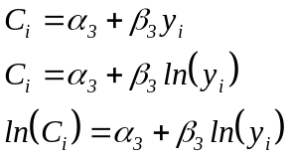
Food Energy Intake method. For each household total calorie intake is computed based on those commodities for which price and calorie content information is available (representing about 80% of the average value of food expenditure), and divided by the number of adult equivalents in the households using the same scale as before. Regression methods are used to establish a relationship between this variable and the standard of living measure for the household. One issue that arises here is the choice of functional form; linear, semi-logarithmic and log-linear forms were considered, respectively:

Based on the chosen specification, the poverty line can be computed as the value of the standard of living measure for a household which would on average give that household the required level of calories per equivalent adult. The calorie requirement figures used for this study indicate a requirement of 2900 per adult equivalent. In this case though, we are only able to compute C_{i} for about 80% of the food expenditure included in the standard of living measure. For this reason, we instead compute the value of the standard of living measure corresponding to 2500 calories from the food commodities for which both price and calorie content information is available.

Results are sensitive to the choice of functional form, and slightly sensitive to procedures used to identify and exclude outliers. In the same units as for the standard of living measure, the linear specification predicts a poverty line in the range 820,000 – 950,000 cedis, the semi-log specification in the range 800,000 – 850,000 cedis and the log-linear in the range 950,000 – 1,050,000 cedis. Examining the average calories acquired by households with living standards in each of these ranges indicates that though these magnitudes are generally plausible, the log-linear specification may slightly overestimate the poverty line while the others may slightly underestimate it.

Overall though, this method does not succeed in defining a very precise level for the poverty line.

Cost of basic needs method. The initial issue in applying this method is the selection of the group whose consumption basket we will focus on, i.e. the choice of x above. The choice of x may affect the consumption basket, with that of the very poorest probably containing a higher proportion of staple foods and a lower proportion of meat/fish etc. than a group including those who are on average slightly less poor. Four poverty line consumption baskets were considered which provide 2900 kilocalories per equivalent adult per day, these baskets having the same composition as the average consumption baskets of the bottom 20, 30, 40 and 50% of the distribution of individuals ranked according to their standard of living. The basket does change marginally as the value of x increases. In particular, the proportion of the calorie requirements satisfied by staple grains such as guinea corn, maize, millet and rice falls marginally, while the proportions provided by many of the root crops, by fruits, beef and fish increase marginally. Of course as well as reflecting changes in the average living standard of the individuals considered as x increases, it may also reflect different consumption baskets in different areas of the country.

To compute food poverty lines, these poverty line consumption baskets need to be valued at the reference prices (those of Accra in January 1999). This is done using price data from the price questionnaire. The resulting food poverty lines are reported in Table A6.1. As expected the food poverty line increases marginally as x is increased, though the changes are relatively small.

The adjustment for non-food is computed based on a regression relationship between the share of expenditure devoted to food and the standard of living measure expressed relative to the food poverty line, as follows:
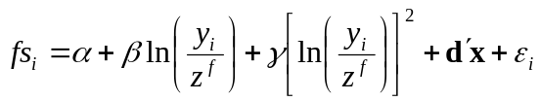

where fs_{i} denotes the share of food in total consumption expenditure for household i, y_{i} its standard of living z^{f} the food poverty line estimated above, x a vector of demographic variables representing household composition, and α, β, γ and d denote coefficients.

The overall poverty line is computed as z^{f}(2 – α) (Ravallion and Bidani, 1994). The regression relationship estimated is given in Table A6.2; the resulting estimates for the overall poverty line are presented in Table A6.1 for the different values of the food poverty line.

Table A6.1: Estimated poverty lines based on different consumption baskets
(cost of basic needs method)

Consumption basket used for food poverty line | Food poverty line | Overall poverty lines
Lowest 20% | 665,300 | 877,900
Lowest 30% | 677,500 | 894,300
Lowest 40% | 694,400 | 917,100
Lowest 50% | 707,600 | 935,000

Table A6.2: Coefficients of main variables in food share regression equations

Variable | Food poverty line based on:
 | Lowest 20% | Lowest 30% | Lowest 40% | Lowest 50%
Intercept | 0.6805 ** | 0.6800 ** | 0.6792 ** | 0.6786 **
ln(y_{i}/z^{f}) | -0.0297 ** | -0.0303 ** | -0.0311 ** | -0.0317 **
[ln(y_{i}/z^{f})]² | -0.0166 ** | -0.0166 ** | -0.0166 ** | -0.0166 **
Notes:
** denotes coefficients statistically different from zero at 1% level.
Other variables included in regression: log (household size), log (number of equivalent adults), number of girls 0-5 years, boys aged 0-5 years, girls 6-14 years, boys 6-14 years, females 15-60 years, males 15-60 years, males > 60 years, females > 60 years.

APPENDIX 7: POVERTY INDICES

Given a suitable measure of the standard of living (denoted as y_{i}) and poverty line (z), it remains to define a convenient means of summarising the principal dimensions of poverty. Essentially, two aspects are of interest: the incidence and the depth of poverty. The former is conveniently summarised as the proportion of individuals in the population of interest who are poor, and the latter by the mean proportion by which the welfare level of the poor falls short of the poverty line. Both of these may be derived as special cases of the widely used P_{α} indices of poverty proposed by Foster, Greer and Thorbecke and defined as follows:

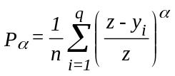

where individuals have been ranked from the poorest (i=1) to the richest (i=n, where n is the population size), where q is the number of economic units reflecting the weight placed on the welfare levels of the poorest among the poor. In the special case in which α = 0, the index reduces to a measure of the incidence of poverty (the proportion of the population defined to be poor):
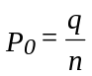

This index takes into account the number of poor people, but not the depth of their poverty. In the case in which α = 1 the index may be written as follows:
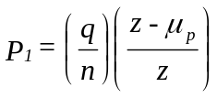

where μ_{p} is the mean income of the poor. The index P₁ is thus the product of the index P₀ and the income gap ratio, a measure of the average amount by which poor households fall below the poverty line. Therefore the P₁ index takes account of both the incidence and the depth of poverty. It is not, however, sensitive to a mean-preserving redistribution among the poor. For higher values of α, increased weight is placed on the poorest of the poor; the P₂ index for example, takes account not only of the incidence and depth of poverty, but also of the distribution among the poor.

Apart from their ability to capture the different dimensions of poverty, another useful feature of the P_{α} class of indices is their property of decomposability. This means that, if the population can be divided into m mutually exclusive and exhaustive subgroups, then the value of the index for the population as a whole can be written as the weighted sum of the values of the poverty indices relating to the subgroups (P_{α,j}, where j = 1, ..., m), where the weights are the population shares of the subgroups (x_{j}):
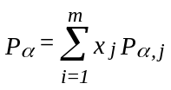

Given this decomposition, the contribution of group j to national poverty can be calculated as c_{j}:
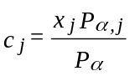

Decomposition of P_{α} indices is used in this study as the basis for examining the geographic and socio-economic pattern of consumption poverty in Ghana.

Finally, note that when welfare is measured using a household level variable (as proposed above) it is appropriate to use weights in calculating poverty indices, where the weights reflect the differences in size of different households. These weights are in addition to those used to reflect differences in the probability of selection for different households in GLSS 4 (see Appendix 4).

The use of poverty indices for poverty analysis

 | Pop’n share | Average  Welfare | P₀ | P₁ | P₂ | P₁/P₀ |  | C₀ | C₁ | C₂
Rural Savannah | 20.6 | 826.8 | 0.700 | 0.323 | 0.178 | 0.462 |  | 36.6 | 48.0 | 55.5

To illustrate the use of poverty indices, take the example of Rural Savannah in 1998/1999, and the higher poverty line of 900,000 cedis. The above is taken from Table A1.2 in Appendix 1. The following conclusions can be drawn from this data.

Population share: the proportion of the total population accounted for by people from that locality. In this example Rural Savannah represents 20.6% of the total population.

Average welfare: this is the mean value (expressed in thousands of cedis) of the standard of living measure: total household consumption expenditure per equivalent adult, in the constant prices of Accra in January 1999. The average standard of living in this locality is less than the higher poverty line (900 in the same terms).

P₀: the proportion of the population in that locality falling below the national poverty line, which is referred to as the headcount ratio or the incidence of poverty. Around 70% of those in the sample in the Rural Savannah lie below the selected poverty line.

C₀: the locality’s contribution to the total number of people in poverty (P₀). Of all the people in the sample who fall below the selected poverty line, 36.6% live in the Rural Savannah. This is significantly higher than the sample share, indicating a disproportionate incidence of poverty in this locality.

P₁/P₀: the income gap ratio or the depth of poverty. Those in the Rural Savannah below the poverty line have an average standard of living 46.2% below the selected poverty line.

P₁: the poverty gap index. This measure takes account of both the incidence and the depth of poverty. It gives an indication of the minimum level of resources which would be required to eliminate poverty, assuming that resources could be perfectly targetted to raise every poor person exactly to the poverty line. The amount of money required is equivalent to 32.3% of the poverty line for every person in the Rural Savannah. This amount would then have to be allocated, with perfect targeting, among those in the Rural Savannah who are below the poverty line in order to raise them exactly to the poverty line.

C₁: the locality’s contribution to total poverty, as measured by the poverty index P₁. C₁ is higher than C₀ because there is a greater depth of poverty in the Rural Savannah than in the country as a whole.

P₂: the severity of poverty. This measure is more complex to interpret, but reflects the need to give greater attention to the needs of the poorest. It takes account of the distribution of poverty among the poor, giving greater weight to the poorest of the poor.

C₂. The locality’s contribution to total poverty, as measured by the poverty index P₂. C₂ is higher than C₁; as more emphasis is placed on the depth of poverty (moving from P₀ to P₁ to P₂), the contribution of the Rural Savannah to total poverty in Ghana increases. This reflects the fact that the depth of poverty is higher in this locality than on average for the country as a whole.

The Ghana Statistical Service is publishing simultaneously a separate report on the GLSS 4.
Our intention has been to avoid including too many tables and other technical detail in the main body of this report. This material has been assigned to the appendices. Appendices 1-3 report some main findings of the survey. Appendices 4-7 provide details of the underlying analysis that has been undertaken.
Appiah et al. (1999) also established a decline in poverty during this period, using the same data but a different methodological approach.
This was verified in a World Bank study completed at the same time. See World Bank, Ghana: Poverty Past, Present and Future, Report No. 14504-GH, June 29, 1995, World Bank, Washington D.C.
If a poverty line is set to give a poverty incidence in 1991/1992 of 31.4 percent (i.e. the same incidence reported in GSS, 1995), around 28 percent of the population would then be considered poor in 1998/1999.
Note that the tables presented are based on changes in the proportion of households in a given group owning an asset, rather than acquisition of assets by individual households (which is harder to measure from the questionnaire).
Indeed there is likely to be a systematic bias. Different people may have different perceptions of what it means to be ill or injured. In particular a richer individual might be more likely to report him- or her- self as ill or injured in circumstances that a poorer person would not. This does not matter though for examining the use of health facilities.
A very detailled companion paper published by GSS fully describes the different steps in the computation of the total household expenditures and incomes (THE ESTIMATION OF COMPONENTS OF HOUSEHOLD INCOMES AND EXPENDITURES: A Methodological Guide based on the Ghana Living Standards Survey, 1991/1992 and 1998/1999)
It would be desirable to allow for the different (higher) calorie requirements of women when they are pregnant or lactating, though in practice it is difficult to identify such instances definitively from the GLSS questionnaires.
See Coulombe and McKay (2000) for more detailed evidences.
Note that this Appendix is largely based on the discussion in the Pattern of Poverty study (GSS, 1995, pp. 97-99).
J.E. Foster, J. Greer and E. Thorbecke, "A Class of Decomposable Poverty Measures", Econometrica, Vol. 52 (1984), pp. 761-766.

